
PRESS RELEASE Date: May, 11 2021

Contacts: Scott Collins, Collins Marketing Communications, +1-216.382.8840; scollins@collins-marcom.com

New Conair AutoWave™ Feature Automates Selection and Use of Multi-Phase, Variable-Speed Wave Conveying

AutoWave™, a new feature of Conair’s multi-phase, variable-speed Wave Conveying™ system for plastics materials handling, makes it easy to automatically select and use capabilities to protect valuable resins from damage caused by dilute-phase conveying systems operating at excessive speeds.

Designed as a “bolt-on” addition to Conair’s SmartFLX control, AutoWave signals the next stage of development for Conair’s Wave Conveying system, the first resin-conveying system to allow use of multiple conveying speeds and phases. Wave Conveying can move resin in dense material “pulses” (Wave Pulse phase); gentle, rolling “streams” (Wave Stream phase); or conventional, but speed-controlled dilute phase.

Wave Conveying was developed to eliminate the problems associated with dilute phase conveying, which moves resin at speeds that are fast enough to damage the resin through friction/rubbing or impact/shattering. This, in turn, results in resin waste, angel hair, and fines, and maintenance problems with clogged filters, overheated pumps, or sluggish conveying performance. Especially when abrasive, filled or reinforced resins are transported at high speeds, tubing elbows and some receiver parts can easily wear to the point of failure. There are a number of ways to compensate for these problems but Wave Conveying actually can eliminate them.

“However,” says Nick Paradiso, Conveying Products Manager for Conair, “until now, successful use of Conair Wave Conveying technology has required users to manually program a series of parameters – a conveying recipe – into the conveying control for each receiver in a conveying system. Then, if the recipe needed refinement, additional manual programming or parameter changes would be required.

“The AutoWave feature eliminates virtually all of that manual programming effort” he continues. “Now, to convey a particular resin, a user needs only to use the new Conair SmartFLX HMI to select a source and destination, then open up a new, simplified receiver control screen and select a desired conveying phase – Wave Pulse, Wave Stream or Dilute. The AutoWave feature coordinates with the SmartFLX control and Wave Conveying components to complete the job”

To keep each conveying cycle “in phase,” AutoWave relies on logic and processing power housed in a supplemental PLC, which links to the same high-speed PowerLink™ network that is shared by the SmartFLX conveying control and all primary conveying equipment. In operation, the AutoWave PLC constantly monitors inputs from Wave Conveying sensors and components; processes them through intelligent conveying algorithms; then, if needed, adjusts the conveying cycle in real-time to assure “in-phase” performance. Because AutoWave continually logs (and references) the real-time adjustments it is making, every conveying solution is optimized with continued use.

Paradiso compares the automated conveying capabilities provided by AutoWave with the adaptive functions of an automobile engine computer, since both continually monitor and manage current performance settings while identifying, “learning,” and then avoiding settings associated with system instability or suboptimal performance. He adds that unlike an engine computer, which is factory programmed, the AutoWave PLC always allows for manual intervention and the addition of new, custom programs.

“This is the closest thing there is to plug-and-play variable-speed conveying,” Paradiso concludes.

Conair Group (www.conairgroup.com) offers innovative auxiliary equipment solutions to plastics processors around the world. With 32 degreed engineers, including 16 senior team members with an average of over 23 years of experience, Conair brings unparalleled technical expertise and support to its customers, guaranteeing its products will deliver maximum productive uptime. Twenty parts and service team members respond to tens of thousands of calls each year, answering in an average of about 15 seconds. Over 450 individual products include resin drying systems, blenders, feeders and material-conveying systems, temperature-control equipment and granulators. Extrusion solutions include line-control systems, film and sheet scrap-reclaim systems and downstream equipment for pipe and profile extrusion. Conair also has specialized expertise in every major end market -- such as packaging, medical, transportation, building and construction, and many others – and strives to ensure plastics processors succeed in today’s competitive global marketplace.

—Ends—

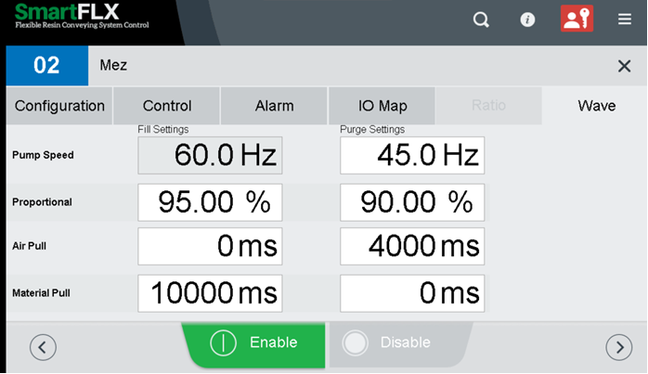
Caption: The Conair AutoWave feature eliminates the need to manually program a series of Wave Conveying parameters into a receiver control screen (top). Now, with the AutoWave feature, users need only select the desired conveying phase from a drop-down menu and AutoWave does the rest (bottom).

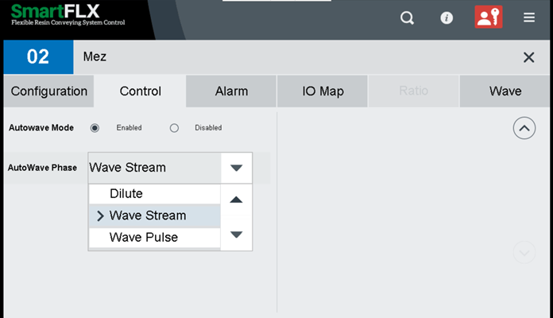
Click here to download the screen images:
Manual Wave - http://www.collins-marcom.com/wp-content/uploads/Manual-Wave-programming-Before-Auto-Wave.jpg

AutoWave - http://www.collins-marcom.com/wp-content/uploads/AutoWave-Phase-Selection-Menu.jpg

