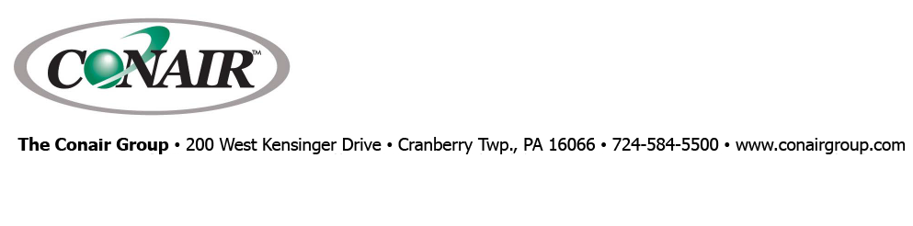
PRESS RELEASE Date: November 8, 2021

Contacts: Scott Collins, Collins Marketing Communications, +1-216.382.8840; scollins@collins-marcom.com

Conair Group Names Jason Ganim President

Jason Ganim, whose background includes almost 30 years of success in sales, management and executive leadership, as well as a degree in Finance, is the new President of Conair Group, effective Monday, Nov. 8.

“We interviewed many highly qualified candidates from a number of industrial equipment companies and several other industries,” said Kirk Winstead who has been Conair President since 2018, while also serving as President and COO of Conair’s parent company, IPEG, Inc. “Our key objective was to attract an accomplished executive with a proven track record of leadership and delivering consistent results in a competitive environment. Moreover, we sought a leader capable of enabling and inspiring our people in order to transform challenges into opportunities.

“As Conair continues to experience phenomenal growth, we need to expand our capacity to serve our customers and maximize our effectiveness across the business,” Winstead continued. “Jason Ganim brings to us leadership experience across a number of industrial and manufacturing businesses, as well as an eagerness to learn all about our industry, products and customers.”

Most recently, Ganim was a senior executive for Transtar Industries, Cleveland, a leading distributor of automotive aftermarket parts and solutions. He held multiple high-level positions during his 13 years with that company. He was Vice President Business Development for East West Manufacturing, Atlanta, for just over 5 years before that, and, earlier in his career spent 6 years as Director of Aftermarket Business for a large distributor of automotive and industrial replacement parts. He holds a Bachelor of Business Administration degree from the University of Georgia, with special concentration in Finance.
For his part, Ganim said he is “a big fan of the culture at Conair. They are a high-value, market-leading company, with a very strong focus on helping customers solve problems, which has always been one of my personal passions. I like the fact that they are committed to involving their employees in the process, soliciting and implementing their ideas and focusing on employee development and continuous improvement. From the first time I visited Conair, I sensed a real feeling of family in the organization and I can’t wait to get involved.

Conair Group (www.conairgroup.com) offers innovative auxiliary equipment solutions to plastics processors around the world. With 32 degreed engineers, including 16 senior team members with an average of over 23 years of experience, Conair brings unparalleled technical expertise and support to its customers, guaranteeing its products will deliver maximum productive uptime. Twenty parts and service team members respond to tens of thousands of calls each year, answering in an average of about 15 seconds. Over 450 individual products include resin drying systems, blenders, feeders and material-conveying systems, temperature-control equipment and granulators. Extrusion solutions include line-control systems, film and sheet scrap-reclaim systems and downstream equipment for pipe and profile extrusion. Conair also has specialized expertise in every major end market – such as packaging, medical, transportation, building and construction, and many others – and strives to ensure plastics processors succeed in today’s competitive global marketplace.

—Ends—
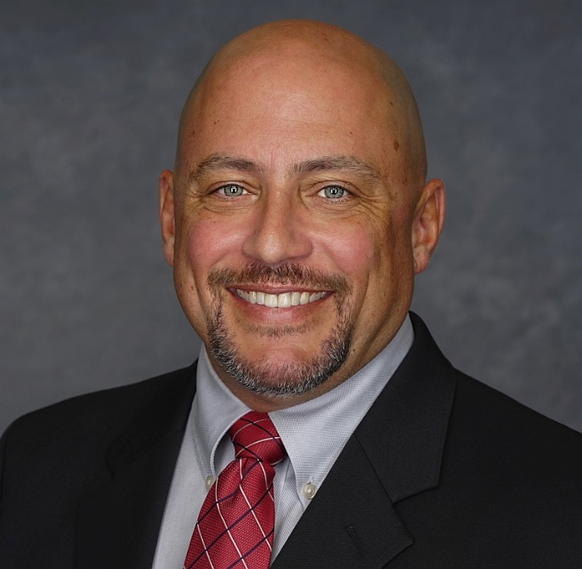
Jason Ganim, New Conair President
Click here to download a high-resolution image: http://www.collins-marcom.com/wp-content/uploads/Headshot-2-Tie-JG.jpg

