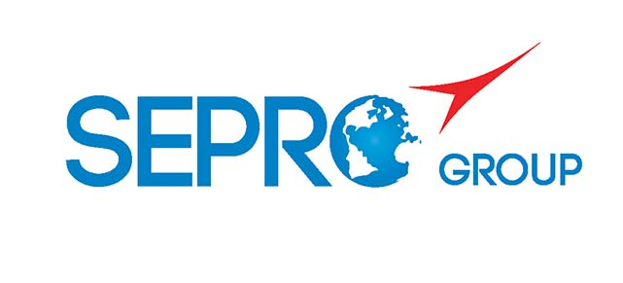 | Sepro Robotique  Rue Henry Bessemer, Zone Acti-Est  CS 10084 -85003 La Roche-sur-Yon  France  Phone: +33 2 51454700
PRESS INFORMATION

16 October 2019

CONTACT: Jean-Sebastien Clement, Sepro Group - France, +33 (2) 51 45 46 35; jclement@sepro-group.com Scott Collins, Public Relations, +1.216.382.8840; scollins@collins-marcom.com

Sepro Group Demonstrating
Robot/Human Collaboration at K 2019

Sepro Group is presenting two examples of interaction between humans and robots in separate demonstrations on the company’s stand (Hall 12, Stand A49) at the K 2019 plastics show, which is being held October 16 – 23 at Messe Dusseldorf in Germany.

Sepro, the global leader in the field of robots and industrial automation for the plastic industry, recently signed a cooperation agreement with Universal Robots, market leader in collaborative robots. That partnership allows Sepro to integrate cobots into the automation solutions it develops for injection molders.

Sepro is well-known for developing molding cells that can involve multiple robots and specialized end-of-arm tooling (EOAT), plus a variety of feeders (bowl, drawer or manual), inspection devices, cavity separation, degating/trimming, box filling and other equipment – all customized to suit specific manufacturing objectives. The partnership agreement with Universal robots means that Sepro can now also incorporate cobots, where applicable, into these automation systems.

For instance, if a cobot were used to stage inserts for pick-up and placement by a conventional Cartesian or articulated-arm robot, human operators could safely refill the insert feeder while the cobot was operating. In contrast, a conventional robot would need to be guarded with physical barriers or proximity sensor to protect the operators. Or, a cobot could be used to perform some simple post-mold task and then hand the part off to a human operator for more complex finishing steps.

Sepro Product Marketing Director Claude Bernard says “cobots are perfectly adapted to peripheral operations that require human-machine interactions… increasingly in demand in the plastics industry. By combining Sepro’s experience in plastics molding with the collaborative technologies of Universal Robots we can offer our customers even greater flexibility and performance in these systems.”

On the Booth
In one demonstration, a cobot serves as the link between a Haitian International molding machine, equipped with a Sepro Success 11 Cartesian robot, and visitors participating in the demonstration. As the molding machine produces drinking cups, visitors can use a key pad to enter a brief message (a name, for instance) that is printed onto a label. After the Success robot removes the cup from the injection mold and places it on a table, the cobot retrieves it, applies the label and presents the personalized cup to the visitor. In keeping with the K show theme related to the Circular Economy, the label and the cup are recyclable.

A second cobot is running in a stand-alone demonstration of robot/human interaction. Visitors to the booth use a control screen to choose between a round box of candy and a square one. With the help of a flexible-feeding system -- provided by the Swiss company Asyril SA – and input from a machine-vision camera, the cobot picks the appropriate shape from the feeder and places it on a table in front of the visitor.

About Sepro
Sepro was one of the first companies in the world to develop Cartesian beam robots for injection-molding machines, introducing its first CNC controlled “manipulator” in 1981. Today, Sepro Group is one of the largest independent sellers of robots in the world, offering a wider choice of robots than any supplier in the plastics industry. Three-, five-, six-axis servo robots and cobots, special-purpose units, and complete automation systems, are all supported by the Visual control platform developed by Sepro especially for injection molders. This unique controller is a key component in what the company refers to as ‘open integration’ – a collaborative approach to equipment connectivity and interoperability that can be tailored to exactly suit the specific needs processors and injection-molding OEMs. At Sepro, customers “Experience Full Control.”
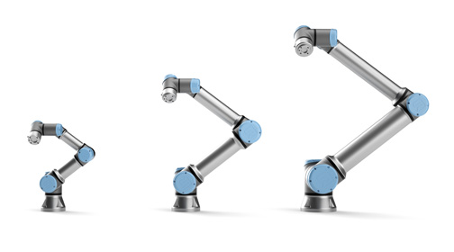
XXX

Through a partnership with Universal Robots, Sepro in able to integrate cobots into the automation solutions it develops for injection molders. Download a high-resolution file at: https://tinyurl.com/SRO-cobots

