
PRESS RELEASE Date: May 11, 2021

Contacts: Scott Collins, Collins Marketing Communications, +1-216.382.8840; scollins@collins-marcom.com

Conair Implementing a Common Control Platform
For All Its Plastics Auxiliary Equipment

Aiming to deliver a more consistent user experience and make it easier for employees to learn the operation of multiple types of auxiliary equipment, Conair is rolling out a new control platform, featuring an HMI that offers a consistent user experience regardless of the machinery involved. The new control platform and HMI have already been implemented in the SmartFLX™ material handling control, truck-fill line-proofing system, blenders, and temperature-control units, with dryers scheduled to be released in Q3 and chillers and other equipment to follow. Other systems, such as Wave Conveying and Conair’s new RFID-proofed resin-selection system are controlled through the SmartFLX Platform.

In addition, all are compatible with SmartServices™, Conair’s cloud-based IoT or “Industry 4.0” solution for machine monitoring and data collection. The Machine Control portion of SmartServices mirrors the same control screen that an on-the-floor operator would see. So, anyone logging into the SmartServices dashboard and using the Machine Control feature will be familiar with the screen setup, and basic operation of the various pieces of connected equipment.

“Having a universal control system on our equipment, will further differentiate Conair in the competitive landscape,” explains Sam Rajkovich, Vice President, Sales & Marketing, “and, more importantly, it will give a leg up to processors. All the buttons will be in the same place, with the same names and color schemes, which will require very little training for an operator as they train on different equipment. We have had that in the past, but only within product lines and not across our full equipment offering. We believe this is the first time any supplier has offered all the major pieces of equipment and central control systems with a common, consistent look and feel from the operator’s perspective.”

Even with the common interface, different auxiliary equipment will continue to use screens of different sizes -- 4.3, 7, 10, 15 inches, and so on – since the complexity and detail of control varies depending on the equipment type. Blender controls, for instance, require more functionality than temperature control units and so the way information is displayed might change. However, the menu structure and navigation, set-point entry, alarm notification, icons, colors, communication protocols, and back-end hardware remain essentially the same.

FUTURE PROOFED
The OPC Unified Architecture (OPC UA) data-exchange standard is the primary protocol for Conair machine controls moving forward and will be standard in all touchscreen-based controls. Since few processors are actually using OPC UA, MODBUS and other standards also continue to be supported. However, when the plastics industry reaches a point where OPC UA becomes the primary machine-to-machine or machine-to-PC communications protocol, the Conair controls will be ready and implementation of true Industry 4.0 practices will be easier than ever.

“Managing rapidly-changing technology is a challenge for our customers as well as for Conair,” says Matt Shope, Director of Engineering. “By leveraging a common control platform, we can implement new features, new hardware, and future-proof communications across all our products with minimal risk to the customer.”

Conair Group (www.conairgroup.com) offers innovative auxiliary equipment solutions to plastics processors around the world. With 32 degreed engineers, including 16 senior team members with an average of over 23 years of experience, Conair brings unparalleled technical expertise and support to its customers, guaranteeing its products will deliver maximum productive uptime. Twenty parts and service team members respond to tens of thousands of calls each year, answering in an average of about 15 seconds. Over 450 individual products include resin drying systems, blenders, feeders and material-conveying systems, temperature-control equipment and granulators. Extrusion solutions include line-control systems, film and sheet scrap-reclaim systems and downstream equipment for pipe and profile extrusion. Conair also has specialized expertise in every major end market -- such as packaging, medical, transportation, building and construction, and many others – and strives to ensure plastics processors succeed in today’s competitive global marketplace.

—Ends—
See photos next page.

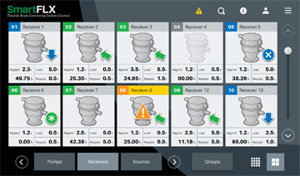

To simplify training and operation of many types of auxiliary equipment, Conair is implementing a new “common control” platform, featuring an HMI that offers a consistent user experience (menu, navigation, data entry, notifications, icons, colors, communications) regardless of the machinery involved. Note the similarity of the SmartFLX conveying control screen above and the dryer control screen below,

Click here to download the screen image: http://www.collins-marcom.com/wp-content/uploads/FLX-Home-Cards.jpg
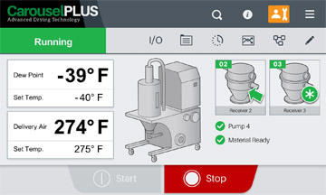

Click here to download the screen image: http://www.collins-marcom.com/wp-content/uploads/7-Dryer-Internal-Electric-Home.jpg

