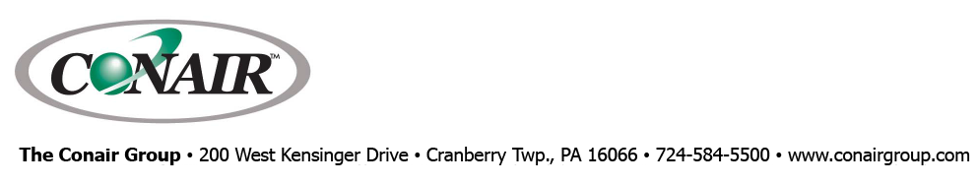
PRESS RELEASE Date: February 11, 2020

Contact: Scott Collins, Marketing Communications +1-216-382-8840; scollins@collins-marcom.com

At MD&M West 2020
Conair and Partners Producing IV Tube
and 3-D Filament on Medical Extrusion Line
Conair Group, together with technology partners Davis Standard and Zumbach Electronics, are demonstrating production of extruded 4.5-mm (0.18-inch) thermoplastic elastomer (TPE) medical tubing and ABS 1.7mm 3-D-printing filament at MD&M West 2020. The demo line, which will highlight the latest technology in extrusion, vacuum sizing/cooling, gauging, coiling, conveying, and quality control, takes place in Booth 4024 of the annual show, which is being held at the Anaheim Convention Center, February 11-13, 2020.

The demonstration marks the first MD&M appearance of the space-saving Conair HTMP multi-pass vacuum-sizing/cooling tank and the ATC Series coiler. Instead of making a single pass through a long tank, the extrudate follows a Z-shaped path so that the compact, 12-ft-long HTMP tank provides cooling time equivalent to a 30-ft tank while fitting neatly into the 20 x 30-ft Conair tradeshow booth. The ATC Series coiler provides tensionless winding of extruded tubing and filament to prevent damage, and is equipped with an automatic coil-isolation safety feature that prevents user access to moving coils.

IV Tube Extrusion
A 2-inch “Super Blue” Davis Standard extruder, equipped with a Touch Panel Control is at the head of the production line. Its output is supported by Conair upstream and downstream equipment, with downstream measurement and monitoring provided by Zumbach Electronics. The TPC integrates all these downstream inputs for complete line control through a single HMI. The demonstration line can deliver production rates up to 400 ft/minute.

On the first two days of the show (February 11 & 12), the line is producing 4.5mm IV tube made of clear thermoplastic elastomer (Teknor Apex Medalist®). TPE is a popular choice for medical tube applications because it offers good weldability, enhanced gamma stability, and excellent clarity, flexibility and kink resistance.

The TPE resin is delivered to the extruder feed throat through a self-contained Conair Access™ Series AL-2 mini-loader. After processing through the extruder, tubing leaves the die and immediately enters the Conair HTMP multi-pass tank. The tank is the first of four MedLine® auxiliaries on display by Conair: all are medical-grade variants of proven Conair auxiliary equipment designs that are specially sized, configured, documented, and supported for cleanroom applications.

“Floor space in any manufacturing plant is costly,” says Ernie Preiato, VP – Extrusion Sales, “and even more so in a cleanroom environment. Considering our multi-pass tanks occupy only about a third of the space a full-length, single-pass tank requires, the savings and convenience are considerable.”

The HTMP tank uses a series of motorized sheaves to gently pull extrudate through cooling water, starting with a 6-ft vacuum chamber that creates a positive differential in air pressure within the extruded tube. This slight outward pressure helps stabilize tube dimensions before additional cooling passes while preventing any “drool” of cooling water out of the tank’s feed opening that could mar the surface finish of the product. At the same time, a pair of Zumbach Electronics ultrasonic gauges – one each near the tank entrance and exit – continuously monitor and report changes in tube wall thickness on a control screen as the tubing cools. Further downstream from the tank, a Zumbach 3-axis OD laser gauge provides not only closed-loop dimensional control, but also displays the tube profile for concentricity adjustments. Together, data from the ultrasonic and laser gauges are used to regulate puller speed and cooling-tank vacuum to maintain critical tube dimensions over the production run.

Because precise temperature control is also essential to proper extrudate drawdown and sizing, the HTMP vacuum cooling tank is served by a MedLine Thermolator® temperature control unit (TCU) and a Conair EP1A-02 (two-ton) portable air-cooled chiller.

The finished extrudate (tube or filament) then moves through a Conair MedLine Pinch Roll puller. The programmable, dual-servo precision puller is commonly used on high-speed medical tube lines that feed their output onto coilers. In this case, the coiler is a Conair MedLine ATC Series coiler. Its floor-mounted ultrasonic loop sensor monitors the incoming product, automatically adjusting coil speed and traverse motion to wind product smoothly into a military wrap, without the friction or tension that can distort delicate extruded products. As one coil is filled, the dual-spindle ATC Series automatically adjusts, rotating the full coil out of the way, cutting the extrudate, then rapidly transferring it to the empty spindle to continue winding. The unit’s automatic coil-isolation feature locks out access during coil transition, then actuates upper and lower safety gates that isolate the actively winding spindle, enabling users to safely access and remove full coils on the other side of the cabinet.

Like the other Conair MedLine auxiliaries, the coiler is also outfitted in RAL 9000 medical paint on non-contact surfaces, with stainless steel on any product-contact surfaces. It is equipped with a full guarding package that includes an aluminum frame and clear viewing doors that interlock for safety.

3-D FILAMENT PRODUCTION
On Thursday, February 13, Conair and its partners are shifting the extrusion line over to production of ABS 1.7mm 3-D filament for the show’s final day. This demonstration highlights the dramatic growth of 3-D printing as a manufacturing process, answering the questions of many manufacturers who are evaluating the development of their own filament extrusion lines as a way to increase control over filament quality, minimize pre-conditioning requirements, and control costs.

Changing the extrusion line to filament production is straightforward: the only hardware changes involve installing a filament extrusion die and a “pre-skinner,” a non-contact sizing chamber, at the entrance of the HTMP multi-pass vacuum sizing tank. The pre-skinner, engineered at Conair’s Extrusion Laboratory in Pinconning, MI, is a water-filled chamber used to pre-cool and “skin” the surface of the filament extrusion before it comes into contact with calibration sleeves in the vacuum cooling tank. Without the benefit of pre-skinning, the hot filament could repeatedly stick and release on the calibration sleeves, resulting in “chatter” marks that mar the dimensional consistency and surface finish of the extruded product.

The Conair Group (www.conairgroup.com) is a leading global supplier of auxiliary equipment for plastics processors, including resin drying systems, blenders, feeders and material-conveying systems, temperature-control equipment and granulators. Extrusion solutions include line-control systems, film and sheet scrap-reclaim systems and downstream equipment for pipe and profile extrusion. Over 450 individual products solve problems, save energy, cut waste and are easy to use. Conair is also an international company, with long-standing operations in Europe, Asia and Latin America. The industry’s most complete product line, top-flight engineering and unbeatable service, all combine to give processors the confidence they need to succeed in today’s competitive global marketplace.
—Ends—

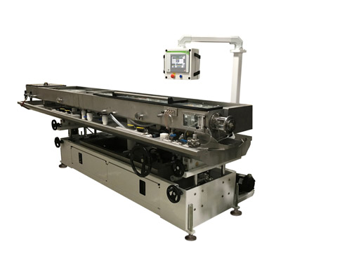
The MedLine HTMP combination vacuum/cooling tank combines the functions of a puller (using motorized sheaves), a vacuum tank, a cooling tank, and an air-wiping device. Download a high-resolution file: https://tinyurl.com/CON-MPTank

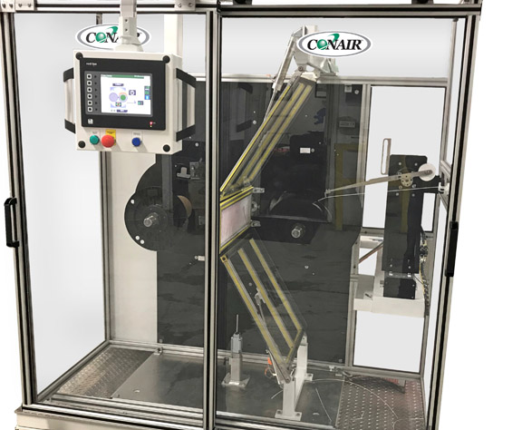
The latest Conair ATC Coiler features a new coil-isolation safety feature that locks out user access during automatic coil changes. Download a high-resolution file: https://tinyurl.com/CON-Coiler

