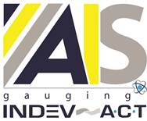

NEWS RELEASE
October 5, 2021

Contact: Scott Collins, Collins Marketing Communications, +1-216-382-8840; scollins@collins-marcom.com

AIS Gauging to Introduce First-Ever Remote Monitoring App

For Web Measurement Gauges at Converting Exposition (ICEC)

Believed to be the first of its kind, a new smart-device app from AIS Gauging, Terre Haute, IN, continuously monitors essential web-process variables, the operational health of the AIS gauges themselves and automatically alerts key personnel if problems arise. The new app, which will be offered with each new gauging system installed, will make its debut at in Booth 1021 at ICEC USA 2021, the International Converting Exhibition and Conference, scheduled for Oct. 19 -21 in Orlando, FL.

The Cloud-based app, called GaugeView, was developed in association with AIS’s push toward total sensor measurement and process control integration into the users Industry 4.0/IIoT environments. The app, which can be downloaded to any smartphone, tablet or other smart device, continuously monitors the operational status of the product measurement system and sends a push-alert if process problems are identified. Users can then make control changes to bring the process back into tolerance, maintaining end-product quality. The app also sends a similar alert to AIS Support Services so they can respond immediately. If necessary, a Support Engineer can securely log into the gauge control – using LogMeIn or a similar remote work tool – investigate the problem further and/or make control adjustments

As an added benefit, the app also monitors the health of the gauging system through 16 key variables for each measurement sensor installed. The variables are then compared to configured limits within the system and the app then delivers a similar push-alert should any attribute drift out of specification. The app can even track mechanical and electrical systems and compare the usage to maintenance intervals and provide push-notifications when services are required. “No other gauging system supplier provides this level of monitoring and support to ensure maximum product quality and system reliability,” says John Young, president of AIS Gauging.

The GaugeView app has a 30-minute memory for storing measured scan results so that support engineers can look back at previous readings when necessary. When no issues are found, the values appear green and any faults that occur are flagged in yellow or red as warnings or alerts. The app also stores a record of all alarms for historical reference.

There is no limit to the number of gauging systems the app can monitor, and a drop-down menu allows users to select the unit and/or sensor they want to view at any given time. The app also has a QR code reader built in and each AIS gauge frame is supplied with a code so that the user can directly view readings for that unit simply by scanning the code.

“We developed this app to give our customers secure and direct access to their process measurement and control system anywhere and at any time.” explains John Young. “However, imagine the peace-of-mind it gives our customers to know their systems are being monitored 24/7 and that, if any issue arises, both the customer and the AIS Support Services team will be alerted to it immediately. “

After the first year of free use, a modest subscription fee will apply going forward.

AIS Gauging is a manufacturer and service supplier of web measurement technologies, providing in-line advanced measurement and control for thickness, coat weight, basis weight and moisture, across a wide range of products. The company began operation in 1998 and has completed hundreds of successful installations around the world, with remote offices in Italy, India and Singapore. Acquired by AIS in 2019, Indev-ACT, Dublin, OH, serves the web and metals measurement and control industries with systems designed to improve productivity, quality and bottom-line yield results. Indev-ACT was originally founded in 1969, and now has manufacturing operations in the US and Europe along with additional service and support offices in China, Brazil, Mexico, Netherlands and Korea. The combined company markets their products within the plastics, coatings, paper, nonwovens, metals and building product industries.
###

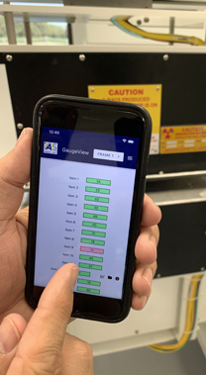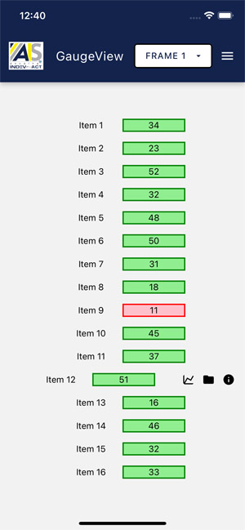
The GaugeView app also monitors the health of the gauging system through 16 key variables for each measurement sensor installed. The variables are then compared to configured limits within the system and the app then delivers a push-alert should any attribute drift out of specification.

Download high-resolution images:
Phone Image: http://www.collins-marcom.com/wp-content/uploads/IMG_0270.jpg
Screen shot image: http://www.collins-marcom.com/wp-content/uploads/Simulator-Screen-Shot-iPhone-12-Pro-2021-08-02-at-12.40.11.jpg

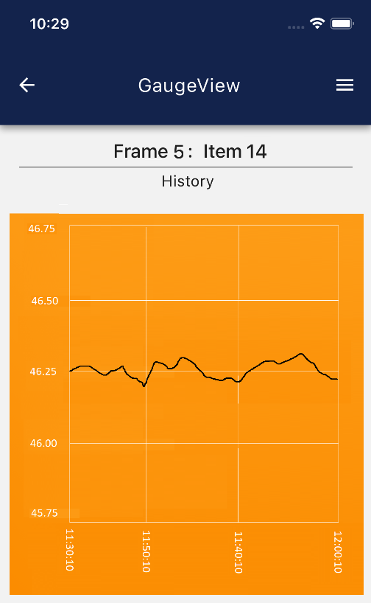
By selecting any one of the monitored variables, GaugeView displays a trend of the last 30 minutes of recorded data.

Download a high-resolution image:
http://www.collins-marcom.com/wp-content/uploads/Alt-History-image.png

