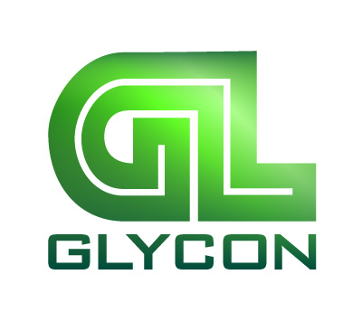 | GLYCON CORPORATION  912 Industrial Dr.  Tecumseh, MI 49286  800-255-9969  PRESS RELEASE
February 10, 2021
CONTACT: Scott Collins, Marketing Communications, 216-382-8840, scollins@collins-marketing .com
Cortney Griffith, Glycon Corp., 800-255-9969, cgriffith@glycon.com

Glycon Announces Top Management Changes

Jeffrey A. Kuhman, founder and owner of Glycon Corp, Tecumseh, MI, has announced major changes to the senior management structure of the Company, a leading manufacturer of feedscrews and related components for plastics processing machinery.

Jonathon L. Kuhman becomes President and Chief Operating Officer and John M. Phelan, formerly General Manager and Corporate Counsel was promoted to Vice President and General Counsel. Jeff Kuhman, who founded the Company in 1978 as Great Lakes Feedscrews, remains as Chairman. The changes became effective as of January 22, 2021, the date of the Company's Annual Board Meeting.

Glycon has been an innovator in screw design for injection molding, blow molding and extrusion, injection non-return valve design and predictive maintenance technology. Additionally, the Company has a major focus on plastics sustainability, working on innovative technology to improve the processability of new bio-sourced polymers and recyclability of conventional hydrocarbon-based plastics.

Previously Vice President of Engineering, Jon Kuhman graduated from Cornell University in Ithaca, N.Y. where he majored in Economics with a minor in Physics, graduating in 1995. He played varsity football for 4 years and received the prestigious Bernie Olin Award his senior year. He joined Glycon Corp. after graduation and worked on the floor in the manufacturing operation. In 1997, he joined the engineering team where he learned screw design and was instrumental in refining the design of Glycon's highly successful QSO® non-return valve. In addition, Jon is recognized as one of the industry's bright young stars in the field of injection and extrusion screw design.

In his new position, Jon will be responsible for all operations and continue to lead the Company in technical innovation and customer service.

John M. Phelan joined Glycon Corp. in June of 2000 as Regional Manager. John graduated from Eastern Michigan University in 1989 with a BS degree and from The University of Toledo College of Law in May of 1997. He was promoted to General Manager and Corporate Counsel in 2009. His new responsibilities as V.P. and General Counsel will include working with Jon Kuhman in planning and managing future growth, as well as all personnel and legal functions including recruiting, hiring and training of new employees and advancement and training of current employees.
Founded in 1978 as Great Lakes Feedscrews, Glycon Corp. is a leading supplier of screws for plastics processes including injection molding, blow molding and extrusion. The Company also supplies the widely acclaimed QSO® non-return valve, plasticating barrels, proprietary feed housings, field engineering services, preventative maintenance, retrofits and rebuilds. Additionally, Glycon has a major focus on plastics sustainability, working on innovative technology to improve the processability of new bio-sourced polymers and recyclability of conventional hydrocarbon-based plastics.
ENDS


Jonathon L. Kuhman
President and Chief Operating Officer
Glycon Corp.
Download a high resolution photo:
http://www.collins-marcom.com/wp-content/uploads/JonKuhman_5x7.jpg
John M. Phelan
Vice President and General Counsel
Glycon Corp.
Download a high resolution photo: http://www.collins-marcom.com/wp-content/uploads/Phelan5x7.jpg

