
PRESS RELEASE Date: April 23, 2020

Contacts: Scott Collins, Marketing Communications +1-216-382-8840; scollins@collins-marcom.com

Hybrid Vacuum Pump Combines Quiet Operation with Long-Distance Conveying Power, Energy Savings

The multi-stage regenerative impeller design of the new Conair HRG Series vacuum pumps is the key to developing deep vacuum power for conveying plastic pellets over long distances, while keeping noise levels comfortably low. An optional variable-frequency drive is available to save energy and makes the new pump ideal for use in Conair Wave Conveying™ systems.

“Until now, processors have had to accept various trade-offs when selecting a central vacuum pump,” explains Rich Shaffer, VP Product Development. “Single-stage regenerative pumps are quiet and inexpensive but limited to short- and middle-distance conveying applications. Positive displacement pumps have been the workhorses of conveying -- powerful and reliable but the low cost versions don’t handle long distances and are noisy. Long-distance pumps (LDP) are special positive displacement pumps that convey over long distances, at high rates, with low noise levels, but they can be quite expensive. Conair’s new hybrid regenerative pumps offers many of the best features of previous designs at a price that is about 30% lower than a comparable LDP unit.”

The secret is in the three-stage pump design, with regenerative impellers that smoothly cut, capture and compress the air with minimal draft or vibration. Like twin turbo chargers on automobile engines, the vacuum becomes deeper and more powerful at each stage allowing the HRG Series pumps to convey material up to 1000 linear feet. Vacuum levels below 12 inches of mercury are possible.

Hybrid regenerative technology makes the HRG pumps extremely quiet. Operating at 60 Hz, the average sound level ranges between 74 and 77 dBA, a comfortable range that does not require hearing protection.

VARIABLE-SPEED OPTION
Equipping the HRG pumps with a variable-speed drive (VFD) motor makes them ideal for use with Conair’s patented Wave Conveying System, which previously required a more costly LDP pump.
Instead of moving plastic materials at 5000 ft/min or more, creating dust, angel hair and equipment wear, Wave Conveying uses controlled speed conveying (300 to 2800 ft/min) to move material in compact slugs, waves or streams.

The VFD also saves energy by allowing the pump to operate using only the amount of power necessary to achieve the desired material speed and throughput. In fact, an HRG pump, running in a Wave Conveying System, was shown to save as much as 50% on energy compared to similarly sized positive-displacement pump at equivalent throughput rates. Even in standard (non-Wave) operation, savings of up to 25% were observed. In addition to energy savings, the VFD option extends pump life by only running at the capacity necessary.

The pumps are available in three different sizes: the HRG-10 has an 11.5-hp motor and is intended for 2.5-inch conveying lines; the HRG-15 (16.9 hp) and the HRG- 30 (42.9 hp) service up to 3-inch line sizes.

The new HRG pumps are also virtually maintenance free. The direct-drive system eliminates drive belts that wear and require constant adjustment. No lubrication is required.

The Conair Group (www.conairgroup.com) is a leading global supplier of auxiliary equipment for plastics processors, including resin drying systems, blenders, feeders and material-conveying systems, temperature-control equipment and granulators. Extrusion solutions include line-control systems, film and sheet scrap-reclaim systems and downstream equipment for pipe and profile extrusion. Over 450 individual products solve problems, save energy, cut waste and are easy to use. Conair is also an international company, with long-standing operations in Europe, Asia and Latin America. The industry’s most complete product line, top-flight engineering and unbeatable service, all combine to give processors the confidence they need to succeed in today’s competitive global marketplace.
—Ends—
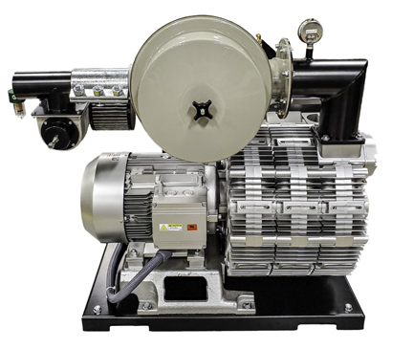
New Conair HRG Series vacuum pumps develop deep vacuum power for conveying plastic pellets over long distances, while keeping noise levels low. Download a high-resolution photos at: http://www.collins-marcom.com/wp-content/uploads/Conair-Hybrid-HRG-Pump_2020.jpg

