PRESS RELEASE Date: January 5, 2021

Contacts: Scott Collins, Marketing Communications +1-216-382-8840; scollins@collins-marcom.com
Chris Keller, CEO, IPEG, +1-724-584-5920; csk@ipeg.net

IPEG Acquires Long-Time Conair Partner Phoenix Systems
Phoenix Systems Corp., a Tustin, CA, supplier of high-volume conveying systems for plastic pellets and powders, has been acquired by IPEG Industrial Group, Cranberry Township, PA parent company of Conair and other leading brands serving the global plastics-processing, waste-recycling, and industrial heat-transfer markets. Financial terms of the deal, which closed on December 21, 2020, were not disclosed.

For more than 20 years, Conair, a global manufacturer of auxiliary equipment for plastics processing, has been collaborating on specialized powder conveying and railcar unloading equipment and technology with Phoenix. The company and its products will now become part of Conair, which already has an extensive family of material-handling equipment.

IPEG President Kirk Winstead said the acquisition “bolsters Conair bulk material-handling capabilities and enhances its ability to serve customers in certain industries, like packaging, which consume high-volumes of material. With that,” he continued, “we also acquire the applications knowledge and intellectual property, which will allow us to more easily develop new products and extend the line further.”

For his part, Leroy Johnson, former owner of Phoenix Systems, feels “fortunate to have had a very successful working relationship with Conair for many years. Conair’s emphasis on excellence in customer service and satisfaction aligned closely with my belief that putting the customer first builds strong and loyal customer relationships. As I considered retirement, it was a natural progression to transition my products into the Conair brand.”

For more information visit our websites:
http://www.ipeg.net
http://www.conairgroup.com
http://www.thermalcare.com
http://www.republicmachine.com
http://www.pelletroncorp.com

See photos next page…


Leroy Johnson
Owner, Phoenix Systems Corp.
Download high-resolution file at: http://www.collins-marcom.com/wp-content/uploads/Johnson-HRDF.jpg

Kirk Winstead
President, IPEG Inc.
Download high-resolution file at: http://www.collins-marcom.com/wp-content/uploads/Chris-Keller-.jpg

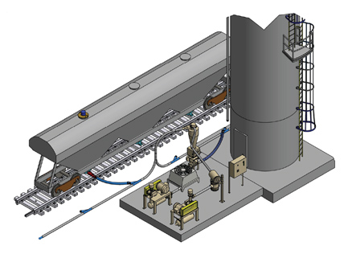
Typical high-volume dual-pump railcar unloading systems offered by Conair can convey up to 30,000 lbs./hr. at distances up to 1000 feet, for line sizes from 4-inch to 6-inch.

Download high-resolution file at: http://www.collins-marcom.com/wp-content/uploads/Conair-RailCar-System@2x-002.png

