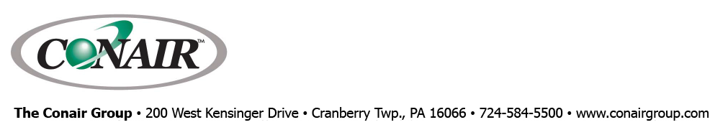
PRESS RELEASE Date: September 9, 2020

Contacts: Scott Collins, Marketing Communications +1-216-382-8840; scollins@collins-marcom.com

PLC Control and Color Touch Screen Added to Conair
EP2 Portable Chillers for Simpler Operation, Monitoring

The newest EP2 Series portable chillers from Conair now include PLC control and a 7-inch color touch screen HMI as standard equipment. Theses chillers – available with air-cooled, water-cooled, or remote air-cooled condensers – use a new sloped top electrical panel that places the large touch screen on the front of the unit at an ideal height and angle for easy viewing and operation.

New capabilities made possible by the EP2 chiller PLC control system include digital pump pressure display, compressor/pump/fan running hours, and performance trend charts for key operating parameters such as process fluid temperatures. The new controls also include Modbus RTU communications as standard to allow easy integration of the chillers with injection-molding machine controls or plant-wide process monitoring systems. In addition, the new control system is fully compatible with the SmartServices™ platform -- Conair’s cloud-based Industry 4.0 solution for auxiliary equipment monitoring, management, and analysis.

An optional, premium EP2 control system provides an expanded PLC system that provides additional communications capabilities like:
- Modbus TCP/IP
- BACnet MS/TP
- BACnet/IP
- LonWorks
- OPC/UA

The Conair EP2 chillers include many industry-leading design features. They are among the most energy-efficient chillers on the market, incorporating standard high-efficiency stainless steel brazed plate evaporators, stainless steel pumps, and Scroll compressors. For maximum flexibility and efficiencies under varying part-load conditions, the EP2 chillers offer variable-speed Scroll compressors technology options on 5-, 10-, 15-, 20-, and 30-ton water-cooled and air-cooled chillers. By automatically adjusting the compressor speed, the optional variable-speed chillers work only as hard as necessary to provide optimum performance with significantly reduced power use.

EP2 air-cooled units are equipped with generously sized micro-channel condensers designed for industrial environments. Water-cooled units use cleanable shell-and-tube condensers and include a condenser-water regulating valve to provide constant head pressure. Remote condenser units are available to direct all heat outside the building.

All EP2 chillers meet severe-duty industrial cooling needs and provide additional resistance to harsh fluid conditions and operating environments. They feature stainless-steel pumps, stainless-steel evaporators, and a process-fluid circuit with corrosion-resistant materials to prevent rust and ensure clean, dependable operation for many years.

The Conair Group (www.conairgroup.com) is a leading global supplier of auxiliary equipment for plastics processors, including resin drying systems, blenders, feeders and material-conveying systems, temperature-control equipment and granulators. Extrusion solutions include line-control systems, film and sheet scrap-reclaim systems and downstream equipment for pipe and profile extrusion. Over 450 individual products solve problems, save energy, cut waste and are easy to use. Conair is also an international company, with long-standing operations in Europe, Asia and Latin America. The industry’s most complete product line, top-flight engineering and unbeatable service, all combine to give processors the confidence they need to succeed in today’s competitive global marketplace.

—Ends—
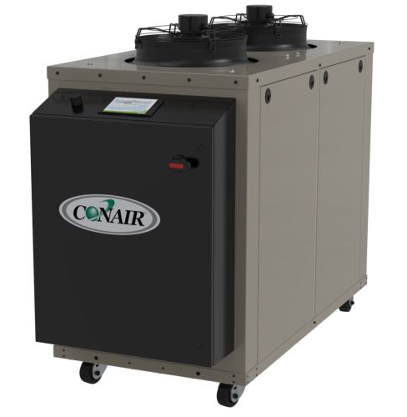
The newest EP2 Series portable chillers from Conair now include PLC control and a 7-inch color touch-screen HMI mounted on a new sloped-top electrical panel for easy viewing and operation.

Download a high resolution photo at:
http://www.collins-marcom.com/wp-content/uploads/EP2-upgrade.tif

