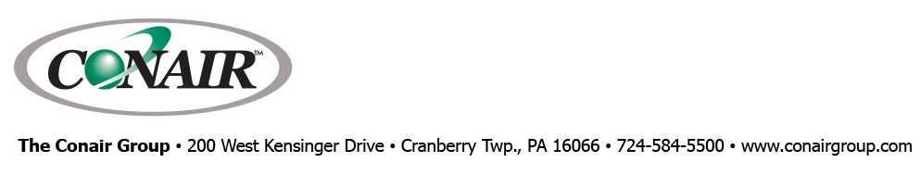
PRESS RELEASE Date: May 11, 2021

Contacts: Scott Collins, Collins Marketing Communications, +1-216.382.8840; scollins@collins-marcom.com

Conair Introduces New Temperature Control Units
Loaded with New Control and Connectivity Features

Few pieces of auxiliary equipment are as basic to plastics processing as temperature control units (TCUs), and yet the newest TW Series from Conair brings a host of new features and capabilities to this “workhorse of the plastics industry.”

The Conair Thermolator® TCUs are still available in three standard configurations:
- The TW-V (V stands for value) are offered with ¾- and 2-hp models, both with a 12kW heater and 3/8” solenoid valve. They offer a smaller footprint than previous versions.
- TW-S mid-range units are sized from ¾ to 10-hp and the units up to 2HP also have a smaller footprint.
- Premium TW-P comes in the same size ranges but with much more advanced features.

All the new Thermolator units feature an ergonomic angled face panel for better viewing of the HMI, and the TW-S and TW-P models are the first units available with Conair’s new “common control,” offering a consistent user experience regardless of the machinery involved. The TCU menu structure and navigation, set-point entry, alarm notification, icons, colors, communication protocols, and back-end hardware will essentially be the same as other Conair equipment, including blenders, dryers, etc. These common features simplify operator training and make it easier employees to learn to use different auxiliaries.

The new Thermolators offer one of the broadest ranges of communications options available in the industry, including Modbus RTU RS-485, Modbus TCP Ethernet and, on the TW-P, OPC UA communication enables for 21st century connectivity. The TW-P is also compatible with Conair SmartServices™, Conair’s cloud-based IoT or “Industry 4.0” solution for machine monitoring and data collection.

Mechanically, the TW-P units can be equipped with solid-state relay (SSR) heater controls that provide the highest levels of precision and long-term dependable operation. They incorporate heat sinks inside the control enclosure and include a beefed-up ventilation fan to dissipate the heat. Mechanical contactors, representing proven technology, and will continue to be offered as standard equipment on all Thermolators.
Also available are modulating valves for cooling in the place of more conventional solenoid valves, which still offer reliable performance and remain available as standard equipment. However, instead of controlling flow by periodically opening and closing like solenoid valves, the modulating valves operate from independent open and close signals so that flow is continuous but controlled. The modulating valves can be opened or closed partially in a linear fashion for greater precision and to eliminate water hammer when flow rates change.

In addition, standard programs can be loaded into the TW-P controller for easy recall. Electrical phase monitoring, an optional flow meter with HMI readout, intuitive help screens for all functions are also provided.

Logically, TW-S and TW-V feature a simpler design. The TW-V has an LCD displays and analog gages. The TW-S has the common-control HMI, with analog gauges as standard (digital optional), and many of the more advanced features of the TW-P also can be added as options.

Conair Group (www.conairgroup.com) offers innovative auxiliary equipment solutions to plastics processors around the world. With 32 degreed engineers, including 16 senior team members with an average of over 23 years of experience, Conair brings unparalleled technical expertise and support to its customers, guaranteeing its products will deliver maximum productive uptime. Twenty parts and service team members respond to tens of thousands of calls each year, answering in an average of about 15 seconds. Over 450 individual products include resin drying systems, blenders, feeders and material-conveying systems, temperature-control equipment and granulators. Extrusion solutions include line-control systems, film and sheet scrap-reclaim systems and downstream equipment for pipe and profile extrusion. Conair also has specialized expertise in every major end market -- such as packaging, medical, transportation, building and construction, and many others – and strives to ensure plastics processors succeed in today’s competitive global marketplace.

—Ends—

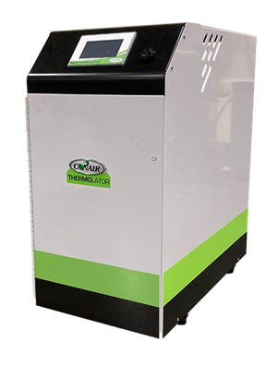
New Conair TW Series Thermolator® temperature control units offer an ergonomic angled face panel with a wide range of communications options, while TW-S mid-range and TW-P premium models feature Conair’s new “common control,” which offers a consistent user experience (menu, navigation, data entry, notifications, icons, colors, communications) regardless of the machinery involved.

Click here for a high-resolution image: http://www.collins-marcom.com/wp-content/uploads/TW-Series-TCU-10May21-HR.jpg

