
PRESS RELEASE Date: July 14, 2021

Contacts: Scott Collins, Collins Marketing Communications, +1-216.382.8840; scollins@collins-marcom.com

Improved ScrapSaver™ Fluff Feeder from Conair Offers Higher Film-Scrap Capacity and Better Reclaim Efficiency

A redesigned ScrapSaver™ fluff feeder from the Conair Group makes high-volume film-scrap reclaim easy by feeding granulated film scrap (fluff) into a stream of virgin material and delivering the mix to an extruder for processing. Designed for use with in-line granulation systems, the latest ScrapSaver feeder features an enlarged and strengthened main hopper and top plate for greater fluff surge capacity, a beefed-up auger and auger shaft to deliver higher fluff-to-virgin ratios to the extruder, an integral control panel, and mounting adapters for varied extruder feed throats from 2 to 8 inches in size.

The special twin-chamber hopper of the redesigned ScrapSaver feeder holds granulated film fluff in a large main chamber and virgin material in a smaller side chamber, keeping both separate until just before they are introduced into the screw flights. To prevent fluff from bridging and keep it flowing smoothly downward, the new ScrapSaver unit employs a longer, stronger one-piece auger, capable of driving higher fluff re-feed ratios to the extruder throat. Virgin pellets feed in by gravity on one side at the base of the auger, maintaining a smoother infeed and a steady fluff-to-virgin ratio.

The enlarged fluff auger is mounted on a new, solid-core auger shaft and powered by a variable speed drive motor (1.5 or 5 HP standard) through a standard 20:1 reduction gearbox. Other optional motors (3 and 7.5 HP) and gearboxes (10:1 or 30:1) are available to handle varying mass-flow rates and bulk densities. The standard feeder enables users to set maximum fluff re-feed ratios of up to 28 percent of extruder output, but can be factory-modified to provide even higher fluff ratios if required.

The ScrapSaver unit mounts, via the appropriate adapter, directly atop the extruder feed throat. The unit is powered and controlled by wiring it through a new, integral control panel that is equipped with displays showing auger speed and auger drive load. This panel can also be equipped with an option to support remote network communications using the Modbus TCP/IP protocol.

The speed of the motor and auger drive are factory-calibrated for precise regulation by a 0-10 VDC reference signal from the customer’s extruder control. In operation, the feeder uses this signal to automatically adjust to any change in extruder rate, maintain the specified scrap/virgin ratio and ensure consistent, surge-free feeding. The drive system comes equipped with current overload protection and status alarms to prolong drive life.

Conair Group (www.conairgroup.com) offers innovative auxiliary equipment solutions to plastics processors around the world. With 32 degreed engineers, including 16 senior team members with an average of over 23 years of experience, Conair brings unparalleled technical expertise and support to its customers, guaranteeing its products will deliver maximum productive uptime. Twenty parts and service team members respond to tens of thousands of calls each year, answering in an average of about 15 seconds. Over 450 individual products include resin drying systems, blenders, feeders and material-conveying systems, temperature-control equipment and granulators. Extrusion solutions include line-control systems, film and sheet scrap-reclaim systems and downstream equipment for pipe and profile extrusion. Conair also has specialized expertise in every major end market – such as packaging, medical, transportation, building and construction, and many others – and strives to ensure plastics processors succeed in today’s competitive global marketplace.

—Ends—

(See attached photo/caption below)
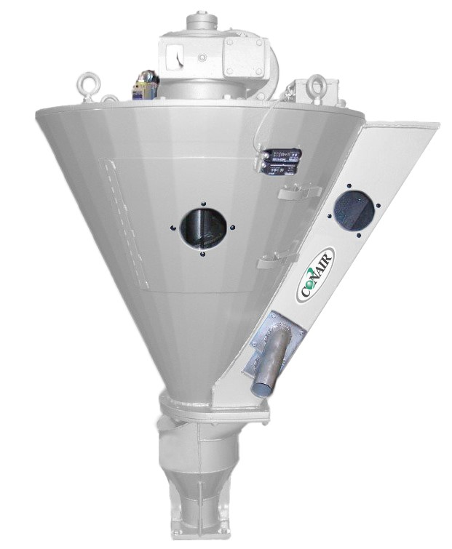
Caption: The redesigned Conair ScrapSaver™ fluff feeder now features expanded main-hopper capacity for larger film-scrap surges and an enlarged and strengthened auger and shaft to deliver higher fluff/virgin ratios.

Click here to download the high-rez screen images: http://www.collins-marcom.com/wp-content/uploads/ScrapSaver_Conair.tif

