 | Sepro Robotique  Rue Henry Bessemer, Zone Acti-Est  CS 10084 -85003 La Roche-sur-Yon  France  Phone: +33 2 51454700
PRESS INFORMATION

7 April, 2020

CONTACT: Jean-Sebastien Clement, Sepro Group - France, +33 (2) 51 45 46 35; jclement@sepro-group.com Scott Collins, Public Relations, +1.216.382.8840; scollins@collins-marcom.com

A message from Xavier Lucas,
Chief Sales Officer, Sepro Group

The unprecedented health crisis that the whole world is going through has altered daily life for everyone. During this complicated period, Sepro Group remains committed to serving it customers, while working closely with our partners and suppliers.

Sepro's main priority is the health of its employees, customers and partners, in compliance with measures taken by the health authorities. Nevertheless, Sepro Group employees are continuing to work as best they can under the circumstances. Our factory is still open and we have taken health and safety measures to ensure that manufacturing can continue, especially to support the needs of essential industries like medical, food, transport, etc.

More than ever, Sepro Group is adapting to the constraints inherent in the situation. Customers are asked to keep us informed about any measures your company has taken that could impact the delivery of robots, spare parts or the intervention by our service team. Any delivery or other intervention will be subject to prior confirmation of customers and carriers.

More information on the actions Sepro Group is taking during this crisis is available on our website at: http://www.sepro-group.com/coronavirus-covid-19-faq/

See photos on next page…

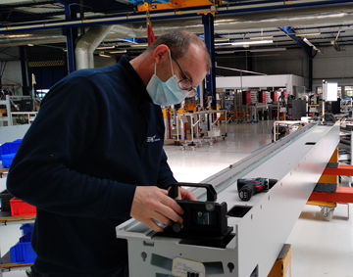
Robot manufacturing continues at the Sepro Group plant in La Roche sur Yon, France
Download a high resolution image at https://tinyurl.com/Sepro-Manufacturing

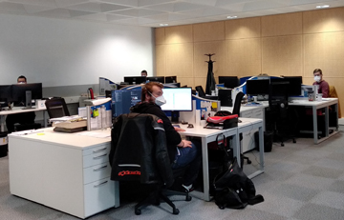
Engineering, Sales and Service staff remain at the service of customers worldwide.
Download a high resolution image at https://tinyurl.com/Sepro-Sales-and-Service

