 | Sepro Robotique  Rue Henry Bessemer, Zone Acti-Est  CS 10084 -85003 La Roche-sur-Yon  France  Phone: +33 2 51454700
PRESS INFORMATION

4 November 2020

CONTACT: Jean-Sebastien Clement, Sepro Group - France, +33 (2) 51 45 46 35; jclement@sepro-group.com Scott Collins, Public Relations, +1.216.382.8840; scollins@collins-marcom.com

Robot Maker Sepro Group is at Your Service

Following the recent guidelines established by the French government in response to the current rebound of COVID-19, Sepro Group is maintaining its momentum and is open and fully operational, says Xavier Lucas, Chief Sales Officer.

The robot and automation manufacturing plant, as well as the logistic center in La Roche-sur-Yon, are working at 100% of capacity, while meeting and even exceeding the health-safety rules and recommendations. Employees who are able to work from home are doing so and all sales, administrative and technical service personnel remain available via telephone and video conferences.

Other commercial operations in Europe, North and South America, and Asia are serving customers, while following health and safety procedures consistent with local regulations and corporate policy. Customer Training Centers, including the two Sepro Academy training centers in France are welcoming guests, as are other centers in Germany and the United States. Depending on local circumstances, training may be conducted in person or virtually.

About Sepro
Sepro was one of the first companies in the world to develop Cartesian beam robots for injection-molding machines, introducing its first CNC controlled “manipulator” in 1981. Today, Sepro Group is one of the largest independent sellers of robots in the world, offering a wider choice of robots than any supplier in the plastics industry. Three-, five-, and six-axis servo robots; special-purpose units; and complete automation systems, are all supported by the Visual control platform developed by Sepro especially for injection molders. This unique controller is a key component in what the company refers to as ‘open integration’ – a collaborative approach to equipment connectivity and interoperability that can be tailored to exactly suit the specific needs processors and injection-molding OEMs. At Sepro, customers “Experience Full Control.”

XXX

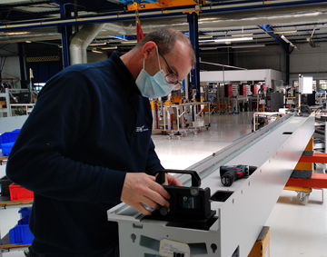
Robot manufacturing continues at the Sepro Group plant in La Roche sur Yon, France
Download a high resolution image at:
http://www.collins-marcom.com/wp-content/uploads/RobotMfgContinues-1.jpg

Engineering, Sales and Service staff remain at the service of customers worldwide.
Download a high resolution image at:
http://www.collins-marcom.com/wp-content/uploads/SalesServiceContinues-1.jpg
