 | Sepro Robotique  Rue Henry Bessemer, Zone Acti-Est  CS 10084 -85003 La Roche-sur-Yon  France  Phone: +33 2 51454700
PRESS INFORMATION

16 October, 2019

CONTACT: Jean-Sebastien Clement, Sepro Group - France, +33 (2) 51 45 46 35; jclement@sepro-group.com Scott Collins, Public Relations, +1.216.382.8840; scollins@collins-marcom.com

Sepro Lab at K 2019 Allows Visitors to Explore
Smart Data Concepts and 4.0 Digital Services

Sepro Group, the global supplier of robots and automation systems for plastics injection molding, has dedicated a special section of its stand at K 2019 to innovative new concepts and digital services.

Called ‘Sepro Lab’ the space allows visitors to see and evaluate some of the company’s most advanced digital developments, including a new Visual Production Dashboard that captures robot operations data to help improve overall plant efficiency. The latest versions of OptiCycle, an automatic robot-cycle optimization system, and Live Support, a maintenance assistant app, are also available for visitors to use. Sepro is exhibiting in Hall 12, Stand A49 at the world’s largest plastics show, which is being held October 16 – 23 at Messe Dusseldorf in Germany.

Smart Data for Molders
In normal operation, the robot control automatically gathers a lot of data from the injection-molding machine and from its own operation. In that sense, Sepro robots are like smart sensors and their data can be used calculate – in real time -- Overall Equipment Effectiveness (OEE), an essential KPI (Key Performance Indicator) measuring the productivity of a plant.

“Robots and IMMs do not collect the same data,” explains Jean-Laurent Lagadic, Electronics R&D Director at Sepro Group. “The molding machine collects data from its own processes, Since it operates at the center of the automation system of the production cell, Sepro’s Visual robot control can aggregate the data produced by the whole cell (IMM and peripherals) with its own measurements. For instance, the robot can measure the rate of good and bad parts produced by the cell. The outstanding connectivity provided by Visual allows Sepro to propose what the customer really needs in order to build the molding plant of tomorrow.”

During the K Show, Sepro will be collecting data from the two injection-molding machines operating on its stand. And, in the Sepro Lab area, visitors will be able to view the KPIs on a Visual Dashboard on the robot control pendant. In the future, this data could also be used as part of a predictive maintenance program.

The system can aggregate data from multiple molding machines on a single platform called Visual Plant, so that molders can evaluate performance across an entire molding plant. The information could be added to an existing MES (Manufacturing Execution System) or presented on a stand-alone computer, as it will be shown in Sepro’s K Show booth.

“There are other systems available to do many of these same things,” says Xavier Lucas, Chief Sales Officer, “but they are not always open, they can be expensive and difficult to use, or dependent on advanced IMM control systems. Visual Dashboard and Visual Plant, on the other hand, can do it all simply and easily by aggregating the production data from all the Sepro robots in the plant. And it does it with existing equipment. Even older robots can be monitored if they have Visual controls. And it all works in real-time.”

Cycle Optimization & Technical Support
The Sepro Lab at K 2019 also offers visitors the opportunity to try out the latest versions of two other control developments, including OptiCycle, a control wizard that helps even inexperienced technicians create optimized robot programs, guaranteeing the fastest possible cycle through the whole factory. OptiCycle can reduce robot in-mold cycle times up to 40 percent and cuts the total injection-molding cycles by about 5 percent, delivering a corresponding increase in productivity.

A second control innovation is a smart-device application called Live Support that simplifies and accelerates customer access to Sepro technical service and troubleshooting assistance. The app links customers and Sepro service technicians and transmits precise, real-time robot information that speeds problem-solving and reduces downtime. In addition, the app supports voice or two-way video communication using a dedicated ‘hotline’ that is already available in France (from 6AM to 10PM) and which will be offered to Sepro’s customers worldwide in the coming months.

About Sepro
Sepro was one of the first companies in the world o develop Cartesian beam robots for injection-molding machines, introducing its first CNC controlled “manipulator” in 1981. Today, Sepro Group is one of the largest independent sellers of robots in the world, offering a wider choice of robots than any supplier in the plastics industry. Three-, five-, and six-axis servo robots; special-purpose units; and complete automation systems, are all supported by the Visual control platform developed by Sepro especially for injection molders. This unique controller is a key component in what the company refers to as ‘open integration’ – a collaborative approach to equipment connectivity and interoperability that can be tailored to exactly suit the specific needs processors and injection-molding OEMs. At Sepro, customers “Experience Full Control.”

XXX

See photo on next page…
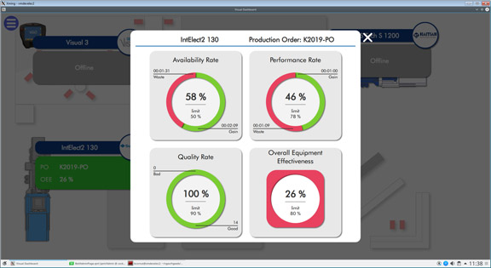
Sepro robot controls gather a lot of production data that can be used to calculate OEE and other metrics for presentation on the new Visual Dashboard.

Download a high-resolution image at: https://tinyurl.com/SRO-OEE

