\  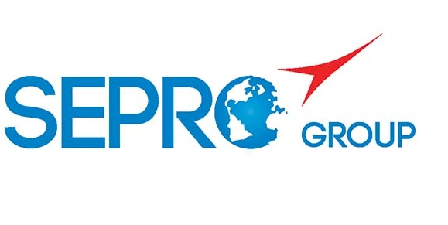 | Sepro Robotique  Rue Henry Bessemer, Zone Acti-Est  CS 10084 -85003 La Roche-sur-Yon  France  Phone: +33 2 51454700
PRESS INFORMATION

27th April, 2020

CONTACT: Jean-Sebastien Clement, Sepro Group - France, +33 (2) 51 45 46 35; jclement@sepro-group.com Scott Collins, Public Relations, +1.216.382.8840; scollins@collins-marcom.com

Sepro, Labotek Agree on India Distribution Pact

Sepro Group, La Roche sur Yon, France, has signed a distribution contract under which Labotek A/S, Frederikssund, Denmark, will sell Sepro robots in India. The agreement is expected to strongly develop the commercial presence of Sepro Group in India, while expanding Labotek’s portfolio of auxiliary equipment for plastics processing.

The contract signing, which took place remotely due to the current Covid-19 confinement situation, was completed on 14th of April 2020.

Robots will be sold under the Sepro brand name by Labotek Plastics Auxiliaries India Pvt. Ltd., the local sister concern of Labotek A/S headquartered in Pune, Maharashtra. Commissioning and service of Sepro robots in India will be handled by Labotek technicians who will be trained at the Sepro factory in France. Labotek maintains a showroom in Pune where robots can be demonstrated and where user training will take place.

“Sepro is serious about growing our business in Asia as part of our strategy to become the world leader in robots for injection molding,” says Xavier Lucas, Chief Sales Officer. “Until now, Sepro has been mainly present on the Indian subcontinent through its large, multinational customers but the distribution agreement with Labotek will give our products much broader exposure.

Yann Laurent, who is responsible for overseas markets, including India, added “We see a lot of opportunity for growth in India, The market for injection-molding machines has grown by more than 17% in the last three years, with the primary markets being automotive, where Sepro has a particularly strong reputation, and also in infrastructure, household goods, agro-food, health and packaging. We expect the demand for automation to increase as local companies strive to increase in production rates and raise the level of quality demanded by increasingly affluent customers.”

For Labotek, the agreement creates an opportunity to offer a more complete package of auxiliary equipment to injection molders, which already includes plastic material storage and handling equipment, dryers, dosing and mixing systems, chillers and mold-temperature control units. The Indian subsidiary maintains sales offices in most major cities and serves customers throughout the country. Labotek India was founded in 2014.

“Labotek India has long been searching for an industrial automation company in order to offer our customers a complete package of auxiliary equipment, for the benefit of time savings and better utilization of their capacity. After researching the market, the choice fell at the Sepro Group due to their outstanding, flexible and innovative solutions and not least: Their 40 years of experience in the market” says Managing Director Jasveer Singh Grewal, Labotek India. ”I look very much forward to our cooperation and to introduce the Sepro robots to our customers”.

About Sepro
Sepro was one of the first companies in the world to develop Cartesian beam robots for injection-molding machines, introducing its first CNC controlled “manipulator” in 1981. Today, Sepro Group is one of the largest independent sellers of robots in the world, offering a wider choice of robots than any supplier in the plastics industry. Three-, five-, six-axis servo robots and cobots, special-purpose units, and complete automation systems, are all supported by the Visual control platform developed by Sepro especially for injection molders. This unique controller is a key component in what the company refers to as ‘open integration’ – a collaborative approach to equipment connectivity and interoperability that can be tailored to exactly suit the specific needs processors and injection-molding OEMs. At Sepro, customers “Experience Full Control.”

About Labotek
Labotek A/S is one of Europe's leading suppliers of plastic industry ancillary equipment, and provides an extensive program of standard and centralized systems. All developed on the basis of the newest technologies and designed to reduce energy consumption to the absolute minimum. The company was founded in 1943. It is 100% Danish owned and maintains a worldwide distribution network of more than 50 dealers and agents. The company has an annual turnover of EUR 16.5 million.

XXX

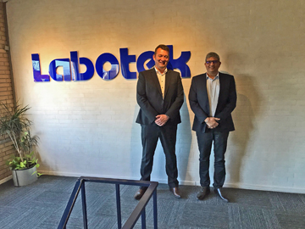
Yann Laurent, Sepro Sales Manager for Overseas Markets, and Jasveer Singh Grewal, Managing Director for Labotek India meet prior to the imposition of Covid-19 travel restriction.
Yann Laurent, Sepro Sales Manager for Overseas Markets, signs the distribution agreement with Labotek from his home office in France.
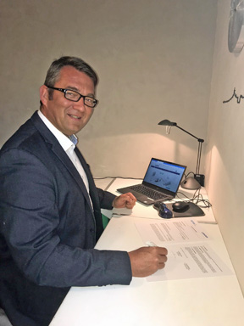

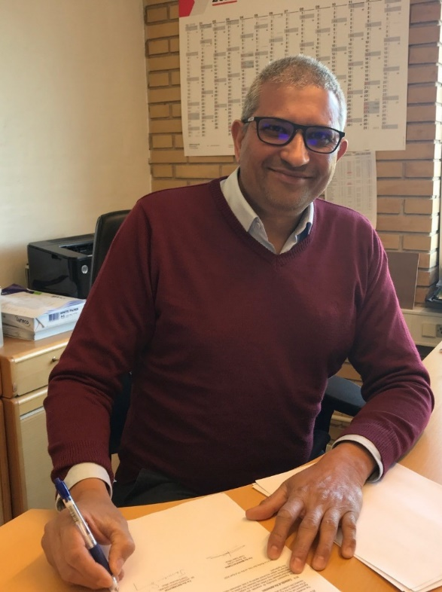
Jasveer Singh Grewal, Managing Director
for Labotek India signs the distribution agreement
with Sepro from his office in Denmark.

