\   | Sepro Robotique  Rue Henry Bessemer, Zone Acti-Est  CS 10084 -85003 La Roche-sur-Yon  France  Phone: +33 2 51454700
PRESS INFORMATION

21 January, 2020

CONTACT: Jean-Sebastien Clement, Sepro Group - France, +33 (2) 51 45 46 35; jclement@sepro-group.com Scott Collins, Public Relations, +1.216.382.8840; scollins@collins-marcom.com

Sepro is Exhibiting at Swiss Plastics Expo

For the first time since beginning direct sales and service to support injection molders in Switzerland, Sepro Group is exhibiting at Swiss Plastics Expo 2020. The company will demonstrate a Model 6X-60 6-axis robot and a 3-axis Success 5 unit at the trade fair, which takes place 21 - 23 January at Messe Luzern.

Sepro Switzerland was formed in 2017. Thomas Scherz, Area Sales Manager, maintains an office in Winterthur, northeast of Zurich. From there, he and a full-time service technician serve the German-speaking areas of Switzerland. The French-speaking western region of the country is covered by Olivier Violy, a 25-year Sepro employee who also covers southeastern France. Customers in the Italian-speaking southeast of Switzerland work with Sepro’s Italian distributor, Sverital SpA.

At Swiss Plastics, Sepro is demonstrating two of its smallest robots in Hall 1, Booth D1084. The first, a Model 6X-60 six-axis articulated-arm robot, is one of four units developed in partnership with Stäubli. Sized to serve injection-molding machines with up to 100 tons of clamp, it has a maximum payload capacity of 9 kg and an operating radius of up to 920 mm. The 6X-60 can handle almost any automation task, from simple part unloading to more complex operations. Other Sepro 6-axis robots are able to serve IMMs up to 5000 tons.

Sepro is also exhibiting its Success 5 robot, the smallest in its “universal” Success line of 3-axis robots for plastics injection molding applications. The Success 5 is designed to deliver big performance in a compact package, offering precise, 3-axis servo performance for pick-and-place and stacking applications on presses up to 80 tons. Four larger models in the Success line – the Success 7, Success 11, Success 22, and Success 33 – can equip molding machines up to 700 tons.

Visitors to the Sepro stand also have the opportunity to get hands-on experience using the Visual control – the control platform that is used to operate all Sepro robots – and lean about various services including:
- Open integration: offering seamless integration of Sepro’s robots and the controls of any IMM via the “Easy Package” approach
- OptiCycle: the Sepro wizard that helps programmers develop a standardized and optimized robot cycle
- Live Support: a smart-device application that streamlines robot troubleshooting and maintenance to maximize uptime.

About Sepro
Sepro was one of the first companies in the world to develop Cartesian beam robots for injection-molding machines, introducing its first CNC controlled “manipulator” in 1981. Today, Sepro Group is one of the largest independent sellers of robots in the world, offering a wider choice of robots than any supplier in the plastics industry. Three-, five-, six-axis servo robots and cobots, special-purpose units, and complete automation systems, are all supported by the Visual control platform developed by Sepro especially for injection molders. This unique controller is a key component in what the company refers to as ‘open integration’ – a collaborative approach to equipment connectivity and interoperability that can be tailored to exactly suit the specific needs processors and injection-molding OEMs. At Sepro, customers “Experience Full Control.”

XXX
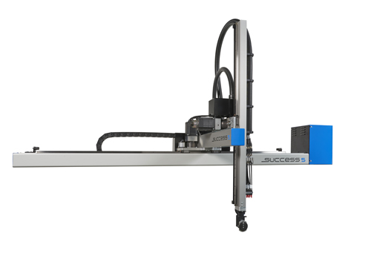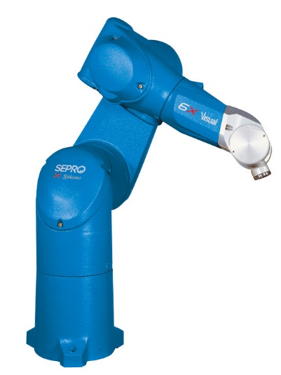
The new Sepro Success 5 offers precise, 3-axis servo performance on injection molding machines from 20 to 80 tons.
Download a high-resolution file at: http://tinyurl.com/kpcp7tp
Model 6X-60 six-axis articulated-arm robot, is sized to serve injection-molding machines with up to 100 tons of clamp.
Download a high-resolution file at:
https://tinyurl.com/SRO-6X60

