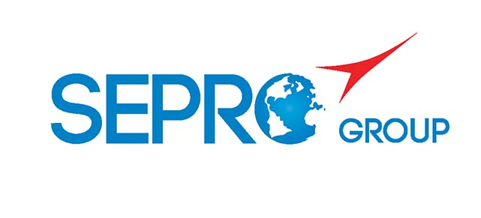 | Sepro Robotique  Rue Henry Bessemer, Zone Acti-Est  CS 10084 -85003 La Roche-sur-Yon  France  Phone: +33 2 51454700
PRESS INFORMATION

8 April 2021

CONTACT: Caroline Chamard, Sepro Group - France, +33 (2) 51 45 46 37; cchamard@sepro-group.com
Scott Collins, Public Relations, +1.216.382.8840; scollins@collins-marcom.com

Sepro Group Establishes
Daughter Company in Switzerland

Sepro Group is creating a wholly owned daughter company to provide more comprehensive sales and service coverage in the country.

“Establishing Sepro Switzerland as a legal subsidiary demonstrates our commitment to customers there,” explains Xavier Lucas, Chief Sales Officer for Sepro Group. “Feedback from customers about the new organization has been really positive.”

Thomas Scherz, Area Sales Manager, leads the organization with support in the French-speaking western region of Switzerland from Olivier Violy, a 25-year Sepro employee who also covers southeastern France. Customers in the Italian-speaking southeast of Switzerland will continue to work with Sepro’s Italian distributor, Sverital SpA. Marcus Klaputek, Sales Director for Sepro Group, also supports the Swiss organization.

The technical service organization has also been reorganized. A full-time service technician covers the German-speaking part of the country and a second technician has been tasked with supporting customers in western Switzerland, with the back-up from Sepro’s local branch in eastern France.

As a leading global supplier of robots, Sepro equips all injection-molding-machine brands from 50 to 5000 tons, whether new or already installed. Sepro’s complete solution includes robots with 3, 5 or 6 axes of motion and all are controlled by the same Visual platform.

Thomas Scherz is a Swiss national who has been involved in sales and key account service in the plastic packaging and industrial equipment industries since 2008. He trained in mechanical engineering and has a Bachelor of Science in business administration and received a Diplom-Ingenieur in sales management in 2017.

About Sepro
Sepro was one of the first companies in the world to develop Cartesian beam robots for injection-molding machines, introducing its first CNC controlled “manipulator” in 1981. Today, Sepro Group is one of the largest independent sellers of robots in the world, offering a wider choice of robots than any supplier in the plastics industry. Three-, five-, and six-axis servo robots; special-purpose units; and complete automation systems, are all supported by the Visual control platform developed by Sepro especially for injection molders. This unique controller is a key component in what the company refers to as ‘open integration’ – a collaborative approach to equipment connectivity and interoperability that can be tailored to exactly suit the specific needs processors and injection-molding OEMs. At Sepro, customers “Experience Full Control.”

XXX

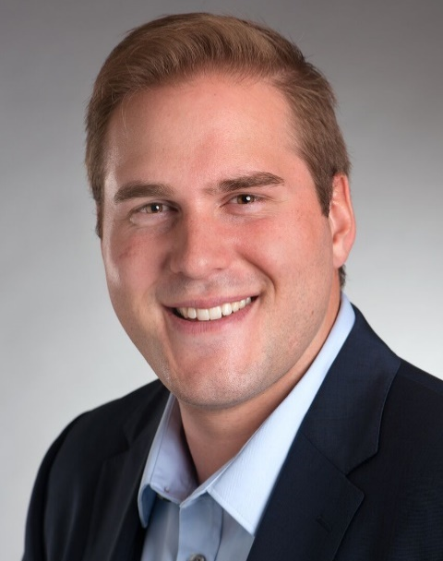
Thomas Scherz, Sales Manager
Sepro Switzerland
Download a high resolution photo: http://www.collins-marcom.com/wp-content/uploads/Thomas-Scherz-HD-1.jpg

