
PRESS RELEASE Date: January 14, 2020

Contacts: Scott Collins, Marketing Communications +1-216-382-8840; scollins@collins-marcom.com

New Conair SmartFLX™ Conveying Control Offers Auto-Configuration, Easy Installation, Cost-Saving Diagnostics

Conair’s new SmartFLX™ conveying control introduces a new system architecture with a more powerful PLC processor, faster and clearer communications, a Universal I/O panel structure, and an intelligent configurator that simplifies and reduces costs for system design and installation, system expansion, and remote diagnostics. Best of all, by leveraging these improvements, many users will be able to adopt the SmartFLX system at a lower capital cost and with lower long-term operating costs than current FLX-128 systems.

Originally introduced in 2009, the FLX conveying control was developed as a “flexible” alternative to complex, large-scale control systems. Users could start small with a basic system of just 8 loaders and 2 pumps (with one back-up pump), and retain the flexibility to increase capacity and capability over time. The original FLX system provides such high-level functions as multi-source/multi-destination loading, ratio loading, reverse common-line conveying for regrind recovery, fill sensing, and more. Over the years, the option to start small has remained, but the maximum capacity of the FLX system has expanded to the point that, when fully loaded, it can manage 40+ pumps, 128 receivers, and 256 controlled sources. In 2018, Conair offered users the option to add slow-speed, dense-phase Wave Conveying™ and Smart Services™ monitoring capabilities to the FLX system.

SmartFLX Architecture supports new, intelligent features
The new “smart” FLX conveying control system incorporates all of the FLX system capacity noted above, but does so with a new system architecture that is easier and more cost-effective to configure, install, manage, and expand,” says Nick Paradiso, Conair’s Product Manager, Conveying Systems. “We named this system SmartFLX because this new platform supports intelligent features: system self-configuration to aid installation, system simulations and modeling to manage system growth, and self-diagnostic and troubleshooting capabilities that eliminate most on-site service calls. The SmartFLX platform will also be the foundation for a wide range of new product additions to be launched around NPE ’21.”

A 10” high-resolution color monitor displays the new SmartFLX user interface, the product of extensive user testing, optimizes menu presentation and keystrokes associated with common user tasks. The interface incorporates a context-sensitive Help system that provides specific instructions for each screen presentation. It operates atop a new PLC processor and software, with all system intelligence centralized in the system’s main panel for easy, single-point software upgrades.

The new SmartFLX architecture separates communications into two channels. Control and diagnostic signaling for Conair equipment travels on a channel built to the lightning-fast, ultra low-noise Powerlink™ standard. This new standard, developed to support crystal-clear data communications in noisy industrial environments, operates at a speed that is more than 6,000 times faster than older communications protocols (e.g., 0.00045 milliseconds vs 3.0 milliseconds). All third-party equipment, as well as system reporting functions, are carried on the second data communications channel, which operates using the versatile and proven Modbus communication protocol.

A key cost-saving feature of the SmartFLX architecture are “universal” system I/O panels. These enable any factory-configured SmartFLX system main panel (and remote or utility panel, when needed), to accept and operate any type of I/O — analog or digital, alarm or HMI, Wave Conveying valves or sensors, or pumps/receivers/loaders/ratio valves — in any available slots. This innovation means that the SmartFLX system can now support greater overall capacity – up to 40+ pumps, 256+ receivers and 500+ controlled sources and all available features – using just three I/O panel types. Operating the same features and equipment – many of which were added to the original FLX control following its introduction – would have required purchase and configuration of up to eight different, dedicated types of I/O panels.

Configurator helps installation, expansion, and troubleshooting
Also unique to the SmartFLX system is a software-based system configurator that simplifies everything from system design and ordering, to installation and expansion, to operations and maintenance/troubleshooting. When provided with initial conveying system and equipment requirements, the configurator can automatically develop an optimized conveying system plan, delivered in a set of current, complete system configuration files. These revision-controlled files can then be used to generate a complete bill of materials, suitable for project ordering, plus detailed electrical schematics and “point to point” I/O maps to guide installation and wiring.

Should system growth be required, the SmartFLX configurator can automatically identify available panel and I/O capacity, assess whether this capacity will be sufficient to meet the additional need, then provide an optimized installation plan. When the installation plan is accepted, the configurator automatically updates all system configuration files so that every detail of the latest installation is preserved.

For help with complex troubleshooting or questions, customers can share current system configuration files with Conair support personnel. Armed with a functional replica of their customer system created by the SmartFLX configurator, Conair personnel can evaluate performance, review equipment duty-cycle data, test alternate settings, or identify fault conditions remotely, without the need for an in-person visit. Then, as issues are resolved, changes can be saved into updated system configuration files and transmitted for uploading by the customer. This breakthrough in remote diagnosis and troubleshooting capability promises huge savings in the cost of system support since, in most cases, on-site service calls can be eliminated.

Looking ahead, Paradiso adds that new SmartFLX product additions are already in the pipeline, with the first to be introduced at NPE ’21. These involve inventory management, line proofing, enhanced system diagnostics, and new Wave Conveying automation. “Several of these products will be introduced virtually at NPE ’21, and we welcome everyone to visit online to learn more.”

Conair Group (www.conairgroup.com) offers innovative auxiliary equipment solutions to plastics processors around the world. With 32 degreed engineers, including 16 senior team members with an average of over 23 years of experience, Conair brings unparalleled technical expertise and support to its customers, guaranteeing its products will deliver maximum productive uptime. Twenty parts and service team members respond to tens of thousands of calls each year, answering in an average of about 15 seconds. Over 450 individual products include resin drying systems, blenders, feeders and material-conveying systems, temperature-control equipment and granulators. Extrusion solutions include line-control systems, film and sheet scrap-reclaim systems and downstream equipment for pipe and profile extrusion. Conair also has specialized expertise in every major end market – such as packaging, medical, transportation, building and construction, and many others – and strives to ensure plastics processors succeed in today’s competitive global marketplace.

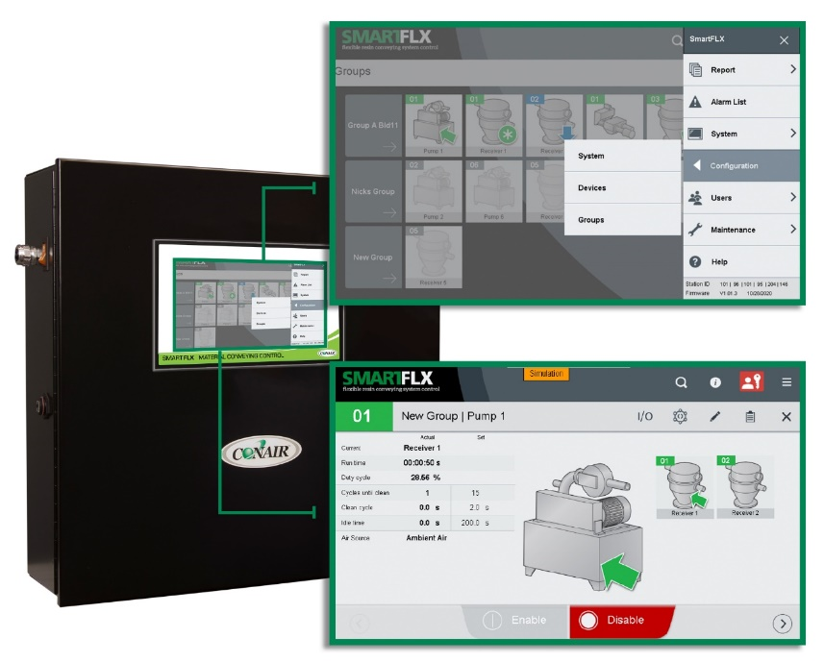
Caption: The expanded 10-inch color touchscreen on Conair’s new SmartFLX conveying control features an optimized menu structure that simplifies system configuration. It enables users to organize material sources, pumps, receivers, and other devices into working groups within the larger conveying system. Each device can be monitored and configured independently.

Download a high-resolution photo: http://www.collins-marcom.com/wp-content/uploads/New_SmartFLX_control_2021.jpg

# # #

