
PRESS RELEASE Date: May 11, 2021

Contacts: Scott Collins, Collins Marketing Communications, +1-216.382.8840; scollins@collins-marcom.com

Conair SmartServices™ Adds Grouping, KPI, and Resin Usage Features, Plus Common Interface for Remote Machine Control
The latest version of SmartServices™, Conair’s cloud-based Industry 4.0 solution for connecting, monitoring, and managing auxiliary equipment, adds new features that give processors added flexibility in equipment monitoring, expanded integration capabilities with non-Conair controls, and a common interface for remote auxiliary equipment control. All of these additions mark Conair’s continued effort to realize the Industry 4.0 goal of exchanging standardized data across machine types and achieving machine-to-machine and machine-to-PC connectivity.
Thanks to expanded naming, grouping, and sub-grouping features, processors can now name and organize equipment and equipment groups for SmartServices monitoring and management in virtually any way they wish—by plant, process, line, or equipment type. These expanded options give processors flexibility to create time-saving scans that “roll up” performance trends, KPIs, maintenance alerts, or priority alarms within a single large equipment grouping. Then, if additional details are required, processors can dig deeper, scanning through varied or specialized subgroups, such as all dryers, all auxiliaries that serve a specific production line, or all TCUs that are due for preventive maintenance.
SmartServices has also expanded its array of real-time trending and Key Performance Indicators (KPIs). Instead of displaying a default set of 3 KPIs for each machine type, SmartServices now offers 10 customizable KPIs and enables users to customize and rank-order all 10 for time-saving, at-a-glance monitoring.
Another new feature, delivered in combination with blender-data logging, simplifies inventory management and production vs. scrap calculations by tracking and storing resin usage and providing on-demand, or scheduled usage reports by blender, or by resin name. What’s new is the fact that these functions are now integrated into the SmartServices platform, which automatically does all software and hardware server-related installation and maintenance of the data. SmartServices then totals information from each blender and stores this data in the cloud, like any KPI or other measurement. The user can then run the resin reports.
Standardized displays, built with non-standardized data
Routine exchange of standardized equipment data is a foundational element of Industry 4.0. However, the protocol for data standardization – OPC UA – is only now being created for plastics machinery controls, so wide-scale adoption by processors is not yet possible.
To bridge this gap and enable the organized presentation of data from auxiliaries not built by Conair, the SmartServices team performs its own custom integration work. This involves reading the data streams of other auxiliary controls that use MODBUS, pulling out relevant data, and integrating it with real-time data from similar auxiliaries for presentation. Until OPC UA is widely adopted, this integration work is essential to processing varied auxiliary equipment data into the neat trend lines, statistical displays, KPIs, and clickable features common to the SmartServices interface.
But the integration effort doesn’t stop there. As Conair implements its newly announced “common” control platform and HMI for its auxiliaries, SmartServices is able to display that same common look and feel in its Machine Control view, which gives authorized users the ability to view and remotely control auxiliary equipment the same way they would on the plant floor. This enables SmartServices to deliver a common remote control interface with the SmartServices platform.
Conair Group (www.conairgroup.com) offers innovative auxiliary equipment solutions to plastics processors around the world. With 32 degreed engineers, including 16 senior team members with an average of over 23 years of experience, Conair brings unparalleled technical expertise and support to its customers, guaranteeing its products will deliver maximum productive uptime. Twenty parts and service team members respond to tens of thousands of calls each year, answering in an average of about 15 seconds. Over 450 individual products include resin drying systems, blenders, feeders and material-conveying systems, temperature-control equipment and granulators. Extrusion solutions include line-control systems, film and sheet scrap-reclaim systems and downstream equipment for pipe and profile extrusion. Conair also has specialized expertise in every major end market -- such as packaging, medical, transportation, building and construction, and many others – and strives to ensure plastics processors succeed in today’s competitive global marketplace.
—Ends—
See illustration next page.

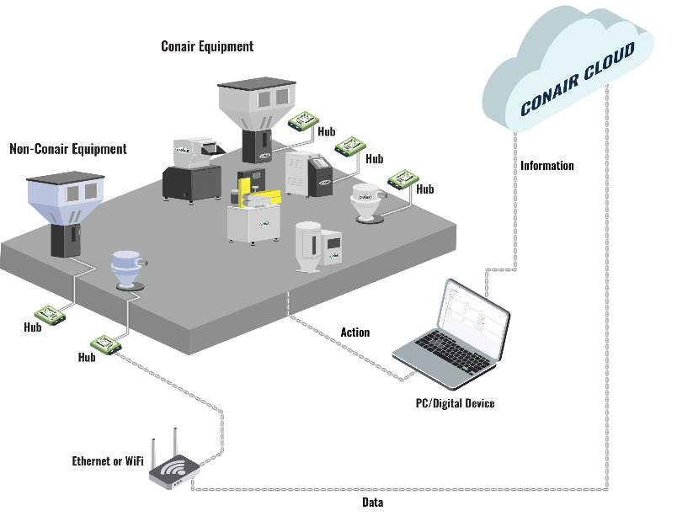
Caption: Through dashboards and displays on connected devices, Conair SmartServices enables authorized users to monitor data and manage auxiliary equipment performance and maintenance, even as it collects the “big data” needed to develop future Industry 4.0 functionality. Latest SmartServices features include added KPI selection/ranking options, flexible equipment groupings for easier monitoring, a common interface for remote machine control, and expanded integration with non-Conair equipment.

Click here to download the illustration: http://www.collins-marcom.com/wp-content/uploads/SmartServices-graphic.png

