
PRESS RELEASE Date: August 25, 2020

Contacts: Scott Collins, Marketing Communications +1-216-382-8840; scollins@collins-marcom.com

New Coil Strapping System for Conair ATC Series Coilers Protects Extruded Tube and Simplifies Handling

A new coil strapping system, now introduced by Conair for its ATC Series tube coilers, automatically and securely straps finished coils of small-diameter extruded tubing. Handling coils up to 24 in (61 cm) in diameter, the system prevents tube damage or unraveling and making the coils far easier to grasp, handle and move. It uses roll-fed PP and PET strapping and is FDA compliant for medical-tube applications.

The optional system comes in two pieces: The first piece is a separate steel stand that holds two large strapping rolls, which is positioned approximately three feet from the end of the ATC Coiler. The second piece is the automatic strapping head unit, which is mounted on a sturdy steel base that attaches directly to the base of the ATC Series coiler on the coil-outlet side. This consists of a strap guide roller, an alignment arm, and a combination strap cutter/welder head that affixes, cuts, and welds the strap material onto the coil. The strapping system control integrates directly with the ATC coiler control via a secure Ethernet communications connection.

In operation, the strapping system is actuated by a signal from the ATC coiler that a full coil of extruded tubing has moved into position. The alignment arm of the strapping system extends to check the coil position, followed by the cutter/welder head. The head attaches one end of the strap to the tube coil, which is then rotated until the wrap is completed. Then, the head cuts the strap material and ultrasonically welds the finished coil strap before retracting. The system can apply one, two, or four straps to a tube coil, based on user selection. (Note: Ultrasonic welding is a vibratory joining process that does not heat or distort finished tubing.)

The strapping system is fed by two 12,700 ft rolls of PE or PET strapping material, each of which contains enough to wrap up to 4,400 coils with one strap or 1,100 coils with four straps. Should strapping material run out, the ATC Coiler’s automatic in-line accumulator ensures that tubing production continues while new strapping rolls are loaded. No line shutdown is required.

The strapping system is available as a factory option for new ATC coilers or as a retrofit for existing units. Conair introduced the dual-spindle automatic cut-and-transfer ATC Series coiler in 2013 to provide tensionless, high-speed winding of small-diameter flexible tubing in sizes from 0.040 inch (1 mm) to 0.5 inch (12.7 mm) on coils up to 24 inches (61 cm) in diameter. The coiler fully automates transfer of tube winding when a coil is full, eliminating the need for operator involvement or process disruption.

Additional ATC Coiler features, including automatic unloading, conveying, and wrapping of strapped coils, are planned by Conair for future release.

The Conair Group (www.conairgroup.com) is a leading global supplier of auxiliary equipment for plastics processors, including resin drying systems, blenders, feeders and material-conveying systems, temperature-control equipment and granulators. Extrusion solutions include line-control systems, film and sheet scrap-reclaim systems and downstream equipment for pipe and profile extrusion. Over 450 individual products solve problems, save energy, cut waste and are easy to use. Conair is also an international company, with long-standing operations in Europe, Asia and Latin America. The industry’s most complete product line, top-flight engineering and unbeatable service, all combine to give processors the confidence they need to succeed in today’s competitive global marketplace.

—Ends—
See photo on next page…

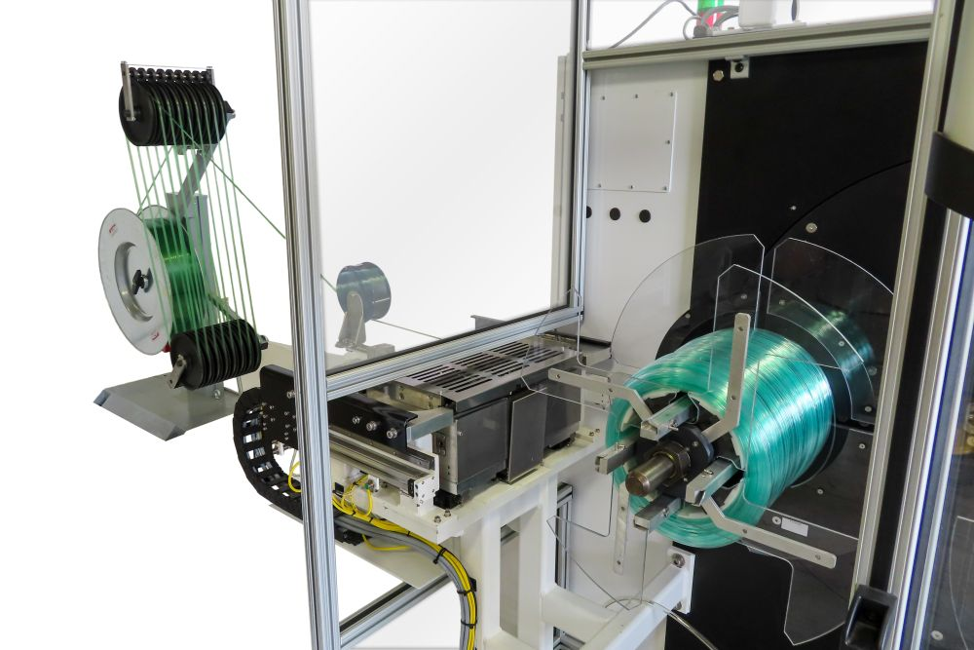
A new coil-strapping system is offered by Conair for its ATC Series Tube Coilers. 3/8-inch strap material feeds from large rolls (extreme left), through tensioners to an automated movable strapping head (center, on slides) that attaches, wraps, cuts, and welds up to four straps on each coil of tube.

Click here to download a high-resolution photo.

