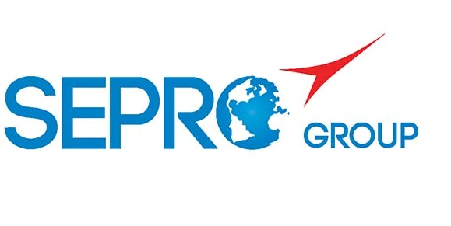 | Sepro Robotique  Rue Henry Bessemer, Zone Acti-Est  CS 10084 -85003 La Roche-sur-Yon  France  Phone: +33 2 51454700
PRESS INFORMATION

16 October, 2019

CONTACT: Jean-Sebastien Clement, Sepro Group - France, +33 (2) 51 45 46 35; jclement@sepro-group.com Scott Collins, Public Relations, +1.216.382.8840; scollins@collins-marcom.com

Success Line X
Sepro Adds a More Affordable 5-Axis-Servo Robot;
Upgrades General-Purpose Success Range

Sepro Group is developing a new 5-axis-servo robot solution as part of a program to redesign its popular Success general-purpose Cartesian robots. Designated as the Success Line X, the 5-axis units will combine the redesigned Success 3-axis platform with a 2-axis servo wrist co-developed with Yaskawa Motoman. A prototype of the new configuration, which will be available in Q3 2020, is on display Hall 12, Stand A49 at the K 2019 plastics show, which is being held October 16 – 23 at Messe Dusseldorf in Germany.

The Success Line X brings new levels of flexibility to general-purpose robotic automation on plastics injection-molding machines from 20 to 700 tons. It expands Sepro’s 5-axis offering, which already includes the 5X Line of small and mid-size robots, and the 7X Line large robots. Both are premium robots that feature a 2-axis servo wrist developed in partnership with Stäubli Robotics. Stäubli and Yaskawa also collaborate with Sepro on a line of 6-axis articulated-arm robots.

“The full servo wrist on Success Line X robots is a feature previously found only on more technological robots,” explains Claude Bernard, Product Marketing Director. “Among other advantages, the servo wrist can be easily adapted with simple digital commands, guaranteeing greater flexibility and faster production changeovers -- approaching Single-Minute Exchange of Die (SMED) methodology. We believe this represents the future of Cartesian robots.”

General-Purpose Flexibility
The Success Line X robots adapt more easily than 3-axis units to quick mold changes, secondary operations and other situations requiring flexibility. This is their primary advantage compared to a simple 3-axis robot with a pneumatic wrist. The positional sensors in the servo motors allow the robot to know exactly where the wrist – and gripper mounted to it -- are positioned at all times. In fact, the robot can move in all 5 axes at any time with complete control. This allows the robot to complete complicated motions. Thus, it becomes easier to extract a large, complex part with minimal clearance between mold halve or tie bars, or to position parts for secondary operations. At the same time, it becomes possible to use simpler end-of-arm tooling (EOAT), since the servo wrist more easily compensates for minor misalignments.

Many of these complex part-manipulation tasks have historically been assigned to 6-axis articulated-arm robots. However, because it is a Cartesian or linear robot, the 5-axis Success X robots offer faster intervention into the mold space for shorter cycle times, while delivering the flexibility inside and outside the mold otherwise associated with an articulated unit. Set-up and operation are highly intuitive and programming was designed to fit the unique needs of injection molding.

Success-ful Redesign
When it becomes available next year, the redesigned Success platform can be expected to carry on the legacy of affordable performance begun when the product line was first introduced in 2011. Four different models, sized for small and mid-sized molding machines up to 700 tons, will continue to be available.

The new generation will have sleek, streamlined styling and features like an extended strip stroke which, in certain applications, can allow a robot of a given size to serve a higher-tonnage molding machine than previously possible.

Sepro engineers also have returned to the use of cam follower bearings for linear motions of the new Success robots. Developed and patented by Sepro some years ago to handle the heavy payloads and long strokes on the large robots, they are now standard on all Cartesian robots. This recognized technology provides more even weight distribution and smoother operation compared to linear bearings and also is more tolerant of dust and other contaminants.

At K 2019, a new Success 22X robot is operating side-by-side a 5X-25, so that Sepro’s full offering of 5-axis robot solutions for small to mid-sized IMMs is represented.

About Sepro
Sepro was one of the first companies in the world to develop Cartesian beam robots for injection-molding machines, introducing its first CNC controlled “manipulator” in 1981. Today, Sepro Group is one of the largest independent sellers of robots in the world, offering a wider choice of robots than any supplier in the plastics industry. Three-, five-, and six-axis servo robots; special-purpose units; and complete automation systems, are all supported by the Visual control platform developed by Sepro especially for injection

molders. This unique controller is a key component in what the company refers to as ‘open integration’ – a collaborative approach to equipment connectivity and interoperability that can be tailored to exactly suit the specific needs processors and injection-molding OEMs. At Sepro, customers “Experience Full Control.”
XXX

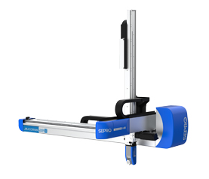
At K 2019, a new Success 22X robot is operating side-by-side a 5X-25, so that Sepro’s full offering of 5-axis robot solutions for small to mid-sized IMMs is represented.

Download a high-resolution image at:
https://www.dropbox.com/s/axc625fndvby5wm/Success22X.jpg?dl=0

