
PRESS RELEASE Date: May 26, 2020

Contacts: Scott Collins, Marketing Communications +1-216-382-8840; scollins@collins-marcom.com

Conair TrueRate® System Automatically Tracks Changes in Resin Inventories, Simplifies Resin Dispensing

The new TrueRate® intelligent inventory tracking system from Conair automatically tracks changes in the inventories of up to 500 different user-specified resins or flowable powders in a processing plant. Developed as an alternative to the use of single-component batch blenders for resin inventory measurement, the new TrueRate system utilizes highly accurate gravimetric measurement.

The TrueRate system is available in two sizes, consisting of an 8-inch weighing ring equipped with two load cells, or a 12-inch ring equipped with three. Both configurations connect to a separate electrical control panel containing a PLC. The weighing ring is mounted below a material loader or receiver but above a container or bin, where it uses resin information provided by the user to precisely calculate the change in weight of the loader/receiver before it discharges the material through the ring and into the container.

The system can operate in two modes:
- In default or “totalizer” mode, the TrueRate system continuously and automatically measures the total resin flow through the receiver to a bin or container below. While doing so, it can display the weight for each load cycle, tabulate a running total (in lbs or kgs), and calculate the total throughput rate for a period of time (lb/hr or kg/hr).

- In job (active) mode, the system adds an optional discharge valve to the weighing ring. This enables the TrueRate system to meter and dose a specified amount of material from the receiver mounted above into a bin or vessel located below. The system senses the amount of material accumulating in the vessel and uses a pneumatic cylinder to close the discharge valve as soon as the correct amount has been dispensed. The cylinder reopens the valve and the receiver cycle resumes when the TrueRate is ready to measure the next batch.

The system can be programmed and controlled in three ways: with an optional 4.3-inch touchscreen built into the system’s electrical control panel, with a Windows-based PC running a virtual network client viewer connected via Ethernet cable to the panel, or with both. Mode selection and programming is very simple. So too is connecting the TrueRate system to SmartServices, Conair’s cloud-based Industry 4.0 solution for auxiliary equipment monitoring, management, and analysis. All that is needed is a SmartServices hub and an Ethernet cable connected to the TrueRate system’s electrical control panel.

“TrueRate is a new and elegant way to track and regulate the receipt, flow, and usage of valuable resins and flowable powders throughout a plastics processing facility,” says Alan Landers, Conair’s Product Manager for Blending. “In totalizer mode, the system can, for example, accurately measure and validate the quantity of resin conveyed from a process bin that was loaded from a silo. Or, it can track the dispensing of that resin to the plant, leaving the processor with an accurate, running inventory,” he explains.

“In job mode, an operator can program the system to measure out a precise amount of material into a bin. For example, you can unload 400 pounds of material into a Gaylord, 25 pounds into a mixer, or 65 pounds into a container that is used to manually fill a rotational mold. Just put the container in place beneath the TrueRate system, and input the desired weight on the control interface. The system will dispense exactly the right amount and stop, so there’s no need for manual weighing and no guesswork or error in tracking the total throughput.”

Conair Group (www.conairgroup.com) is a leading global supplier of auxiliary equipment for plastics processors, including resin drying systems, blenders, feeders and material-conveying systems, temperature-control equipment and granulators. Extrusion solutions include line-control systems, film and sheet scrap-reclaim systems and downstream equipment for pipe and profile extrusion. Over 450 individual products solve problems, save energy, cut waste and are easy to use. Conair is also an international company, with long-standing operations in Europe, Asia and Latin America. The industry’s most complete product line, top-flight engineering and unbeatable service, all combine to give processors the confidence they need to succeed in today’s competitive global marketplace.

—Ends—
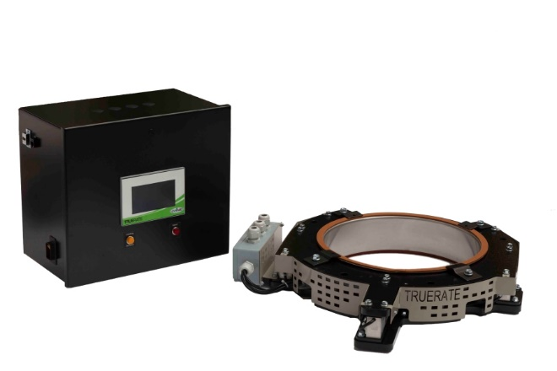
The TrueRate intelligent inventory tracking system from Conair automatically tracks changes in the inventories of up to 500 different user-specified resins. System components include a PLC equipped control panel (at left, upper image) and a weigh ring (at right).

The TrueRate weigh ring is installed under a loader or receiver (lower image), where it precisely calculates throughput before discharging the material into a hopper or other container.

Download high-resolution photos at:
http://www.collins-marcom.com/wp-content/uploads/TrueRate_WeighRing_Control_FINAL.jpg

http://www.collins-marcom.com/wp-content/uploads/TrueRate_installedbelowLoader_FINAL.tif

