 | Sepro Robotique  Rue Henry Bessemer, Zone Acti-Est  CS 10084 -85003 La Roche-sur-Yon  France  Phone: +33 2 51454700
PRESS INFORMATION

26 October 2020

CONTACT: Jean-Sebastien Clement, Sepro Group - France, +33 (2) 51 45 46 35; jclement@sepro-group.com Scott Collins, Public Relations, +1.216.382.8840; scollins@collins-marcom.com

In a Year With No Trade Fairs,
Sepro Group Launches a ‘Virtual Showroom’

One of the world’s largest suppliers of robots and automation solutions for plastics injection molding, Sepro Group has assembled a vast array of equipment and technical expertise in a ‘Virtual Showroom’ (https://www.sepro-group.com/sepro-virtual-showroom-2020 ) that will be online at least until the end of this year. The showroom even allows visitors to view robots in 3 dimensions.

“Despite the cancellation of all trade fairs due to the Covid 19 pandemic,” explains Xavier Lucas, Chief Sales Officer for Sepro Group, “we feel it is important to keep in touch with our clients, our partners and all who seek to automate their production lines. Although it appears only online, we expect it to present a comprehensive view of Sepro technology… almost as if it were a real trade show stand.”

In the Virtual Showroom, visitors can explore the entire Sepro robot portfolio, including:
- The completely redesigned Success Range of 3-axis, and now 5-axis, affordable general-purpose robots
- 3- and 5-axis robots in all sizes
- 6-axis robots, co-developed with industry leaders: Yaskawa Motoman and Stäubli
- Smart data services including Live Support, a live hotline support feature designed to reduce downtime

Perhaps the most exciting feature allows visitors to click into a 3D virtual display where they can study Sepro robots, rotating them through all angles and perspectives, and getting brief text descriptions of key features and capabilities. A menu bar let users choose which robots to study.

Another section of the showroom gives visitors the opportunity to schedule socially-distanced face-to-face discussions with Sepro technical experts on seven different topics about robots and automation in the plastics industry, or simply to share ideas about current and future projects.

Visitors can schedule presentations on the following subjects:
- How to reduce downtime with preventive maintenance
- Fast troubleshooting” best practices and tools
- What EOAT do I need for my application? Discover My Gripper, Sepro’s comprehensive catalog of EOAT components that allow you to build tooling both simple to complex.
- New affordable robots: Success and Success Line X
- Why multi-axis (5 and 6 axis) robot solutions are more flexible.
- Solution by Sepro: the unique Sepro approach to complete turnkey automation systems.

About Sepro
Sepro was one of the first companies in the world to develop Cartesian beam robots for injection-molding machines, introducing its first CNC controlled “manipulator” in 1981. Today, Sepro Group is one of the largest independent sellers of robots in the world, offering a wider choice of robots than any supplier in the plastics industry. Three-, five-, and six-axis servo robots; special-purpose units; and complete automation systems, are all supported by the Visual control platform developed by Sepro especially for injection molders. This unique controller is a key component in what the company refers to as ‘open integration’ – a collaborative approach to equipment connectivity and interoperability that can be tailored to exactly suit the specific needs processors and injection-molding OEMs. At Sepro, customers “Experience Full Control.”
XXX

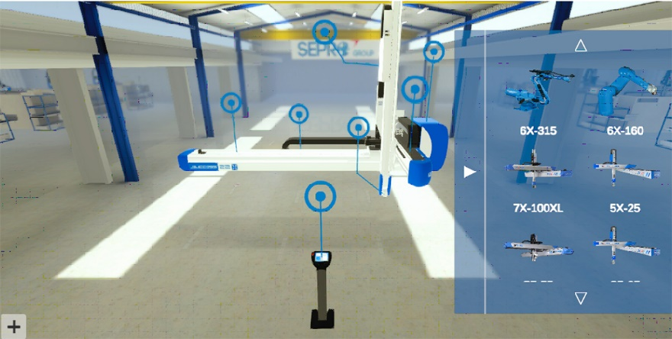
Visitors to the Sepro Virtual Show can click into a 3D virtual display where they can study Sepro robots, rotating them through all angles and perspectives, and getting brief text descriptions of key features and capabilities.
Download a high resolution photo: http://www.collins-marcom.com/wp-content/uploads/3D-Showroom.jpg

