\  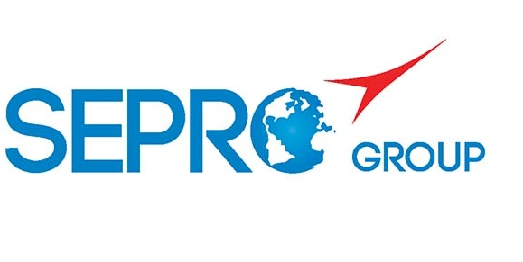 | Sepro Robotique  Rue Henry Bessemer, Zone Acti-Est  CS 10084 -85003 La Roche-sur-Yon  France  Phone: +33 2 51454700
PRESS INFORMATION

17 June 2020

CONTACT: Loic Legendre, Sepro America, +1- 412-459-0462;llegendre@sepro-group.com
Scott Collins, Public Relations, +1.216.382.8840; scollins@collins-marcom.com

Sepro America Offering ‘Virtual’ Robot Training

As the global pandemic continues to limit opportunities for travel and face-to-face interactions, Sepro America, a leading manufacturer of robots for plastics injection molding located in Warrendale, PA, has begun offering a free training webinars to its customers using online meeting systems.

Five webinars are offered, covering:
- Basic use of the control pendant
- Simple pick and place programming
- Editing a program
- Work zones and the IMM interface
- Optimizing the robot cycle.

The webinars, which can be conducted in English, Spanish or French, range in length from 1 to 1.5 hours. They are open to current and new customers using robots with Visual 2 or Visual 3 controls. Participants need a PC with microphone, speakers and webcam and must have internet access with Google Chrome browser. Webinars are limited to 6 students and will be scheduled periodically depending on the availability of instructors and participants.

For more information or to register, visit https://bit.ly/2MMh6QI.

About Sepro
Sepro was one of the first companies in the world to develop Cartesian beam robots for injection-molding machines, introducing its first CNC controlled “manipulator” in 1981. Today, Sepro Group is one of the largest independent sellers of robots in the world, offering a wider choice of robots than any supplier in the plastics industry. Three-, five-, six-axis servo robots and cobots, special-purpose units, and complete automation systems, are all supported by the Visual control platform developed by Sepro especially for injection molders. This unique controller is a key component in what the company refers to as ‘open integration’ – a collaborative approach to equipment connectivity and interoperability that can be tailored to exactly suit the specific needs processors and injection-molding OEMs. At Sepro, customers “Experience Full Control.”

